Genshin Impact Offline (GIO)

Docker VM for ALL versions (CB1,2,3, 1.0.0 - 3.2.0)

Guide version: 13

Date: 2023.05.02





GIO Guide book for braindead

Guide authors 4

Useful links 4

GIO – Genshin Impact Offline server 4

Prepare your hardware 5

Special toolbox server-requirements.rar 6

Download your favorite game client version 6

Patch your game client version 7

Method 5. GIO Dockers configs for all game versions for “braindead” players 8

Prepare your system 8

Configure Fiddler 11

Configure Docker Desktop 13

Download docker configs 15

Download server bins + data for bins 15

Suitable bins + data list: 16

How to use suitable server data 21

How to use suitable server bins 24

NavMesh and SVO (Sparse Voxel Octrees) 26

Start server bins in Docker Desktop 27

Start server bins + data in Docker Desktop 28

Fix WSL Docker memory (aka white game screen after gates) 32

Start fiddler with special fiddler script 32

Useful info about version.txt in CB (Closed Beta) versions 36

Database access (phpMyAdmin) 36

Database access (adminer) 37

Check available versions in Database 38

GM Cheat commands and MUIP tool 41

MUIP Tool sign key 46

How to use GM commands without MUIP Tool 48

Alternate GM GUI 49

All known GM cheat commands 50

Unknown GM cheat commands 52

How to use IDA/HxD/etc to see other GM commands 57

Adjust events time limit 58

Fix buggy 80001 and 20001 quests for 3.2 server 59

Fix Spiral Abyss for 3.2 server 59

Better Solo Mod for 3.2 server 59

Change banners 59

GM mail 59

Disable telemetry 60

Proto – what is that? 61

Proto dumping 62

KCP/Enet and UDP/TCP 63

Proto shifting on the fly using KCP Proxy 64

Method 2. VM-Installer - run server without Docker in Linux/VMware/Virtualbox/WSL 65

Download installer + script 66

Prepare your virtual machine 66

Method 3. Run already prepared server VM image using VMWare only 78

Method 1. Run server in Linux native/WSL without Docker/Vmware/Virtualbox 91

TCG (aka GCG) game from 3.3 support in 3.2 server 111

Do you really read all pages? 113

# **Guide authors**

**Bios#5368, Hotaru#9643, PartyPooper#4658, DiXiao#6611, qawo#0077**

And some unknown authors...

# Useful links

**Our Discord GIO server [Kinky Rooms]:**

<https://discord.gg/MfxYRNdD9x>

**Topic:**

<https://forum.ragezone.com/threads/genshin-impact-leak-docker-vm-for-all-versions-cb1-2-3-1-0-0-3-2-0.1211748/>

# GIO – Genshin Impact Offline server

Players wishing to play Genshin Impact on private servers have been running into a brick wall, because it's completely prohibited by publishers miHoYo. As [Genshin Impact](https://www.ggrecon.com/genshin-impact/) operates a gacha system which allows players to pay both real life and in-game currencies on characters, the game must constantly be online to function. This is despite it being a mostly single-player game, which has left many frustrated and wishing for their own private servers to limit the intrusiveness of the online gacha storefront. With the company line telling players that wishes can be bought with Primogems which are free to earn in the game, many players have expressed their frustration at having to grind gameplay for many hours to accrue enough Primogems to spend. Through social media channels this is a contentious issue, with many agreeing with this point and others arguing that the system is a fair model for a free-to-play-game. Either way, the demand for private servers has only increased with time.

**Using GIO you can play in offline mode with unlimited resources (primogems, etc.)**

# **Prepare your hardware**

- You must have **20+ GB RAM**. It’s not a joke. Better do **32 GB RAM** setup, otherwise you can’t boot it up. **JUST GIVE UP right now if you haven’t enough RAM.**

This is an example of a very bad hardware setup:



This is an example of a very good hardware setup for GIO:



# Special toolbox server-requirements.rar

First - download all-in-one useful scripts that can help you in different start methods:

<https://anonfiles.com/l602F8odz1/server_requirements_rar>

<https://upload.biosnod.ru/download/fecdf2778cb6a1c988c13544cb3eb9c5>

Download your favorite game client version  
  
**All game clients + audio you can download here:**  
<https://file2.yuuki.me/GD1/Project/GenshinImpact/Data/PC>   
<https://github.com/MAnggiarMustofa/GI-Download-Library>

Just extract game archive to some folder (without any launcher). Starting at 1.5.0 game version all audio has different archives (not in game archive). Just extract the audio to the extracted game folder like this:  
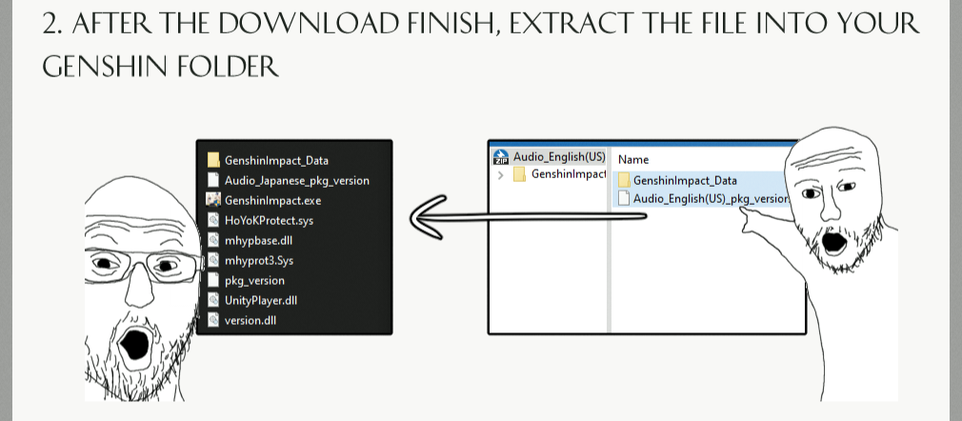  
  
**CB** = Closed Beta Test (Pre-releases before **1.0.0_rel**)  
**CB1** = **CB1 1.0.0** (not to be confused with **1.0.0_rel** after **CB3**!)  
**CB2** = **CB2 0.7.0** (yes, **0.7.0** after **1.0.0** – weird)  
**CB3** = **CB3 0.9.0**

**1.0.0_rel** = **1.0.0** release (not to be confused with **CB1 1.0.0** pre-release!)

Other versions of the game are numbered from **1.0.0** to **3.5.0**+  
Game version **1.0.0** is **NOT** **CB1 1.0.0**. It's different. After **CB1 1.0.0** next version is **CB2** - have **0.7.0** - it's OK, it's just that the game developers have problems with their heads

Patch your game client version

**All patches for all game versions you can download here:**  
<https://anonfiles.com/2bJev3o4za/login_rsa_mhyprot_patches_rar>

<https://upload.biosnod.ru/download/ac1b9d0fe01cbe2f192ab83333f7ba33>  
  
For **CB1** you should use patched **UserAssembly.dll** to skip files checking and your system language should be English only! Otherwise you will see a lot of errors (after gates in game).  
  
For **CB2** and **CB3** you should use patched **mhyprot2.sys** or **mhyprot.sys**  
(otherwise your game will be closed immediately after run, If one doesnt work - try to use another one)  
  
Also for **CB2** and **CB3** (also for **1.0.0, 1.1.0** and **1.2.0**) you should use ProxyCap + Fiddler both (cuz this versions avoid proxy, yeah, ProxyCap will force this versions to use Fiddler), guide for ProxyCap here (read readme.txt inside) -  
<https://upload.biosnod.ru/download/ce8375c48bc2aca65e910d675c149a0e>

<https://anonfiles.com/l0K3vcofz3/ProxyCap_braindead_v2_rar>

**Other versions - Fiddler only without ProxyCap**  
  
For 2.8, 3.0, 3.1 and 3.2+ you should use patched **global-metadata.dat** or **UserAssembly.dll** or **RSAPatch.dll (aka mhybase.dll)**  
  
**You shouldn't do any .dll patches for 1.3.0 - 2.7.0, all works without patches for this versions**

**Patches only for CB1(1.0.0), CB2(0.7.0), CB3(0.9.0) and for 2.8.0 up to 3.2.0+**

# **Method 5. GIO Dockers configs for all game versions for “braindead” players**

Hello, I am one of the contributors of the Docker configs for the servers =)**I can start every game version, CB1, CB2, CB3 and 1.0.0 up to 3.2.0 and I already tested all of them.** All works fine for me, I will help you, just write your troubles in our Discord. I will update this post and provide new Dockers from time to time.

# **Prepare your system**

- For Windows enable WSL (Windows Linux Subsystem) - open Start:

* + Control Panel
  + All Control Panel Items
  + Programs and Features
  + Turn Windows features on or off

Check Windows Subsystem for Linux, click OK, and restart your computer.

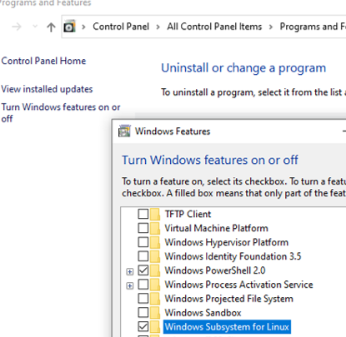

- Install WSL2 update:  
[<https://wslstorestorage.blob.core.windows.net/wslblob/wsl_update_x64.msi>](https://wslstorestorage.blob.core.windows.net/wslblob/wsl_update_x64.msi)<https://anonfiles.com/Y2E8v4o7z2/wsl_update_x64_msi>

Or use wsl_update_x64.msi from the “**server-requirements.rar**”

Also, you can learn about WSL here:

<https://learn.microsoft.com/en-us/windows/wsl/install-manual>

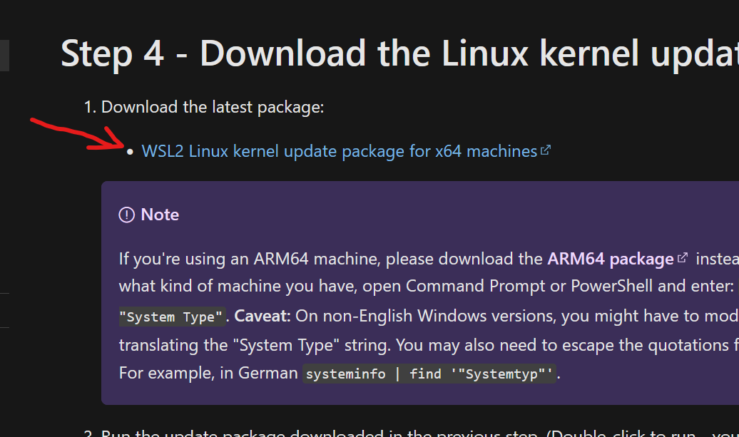

And here: <https://learn.microsoft.com/en-us/windows/wsl/install>

- Install Docker Desktop for Windows or just Docker for Linux

[<https://www.docker.com/products/docker-desktop/>](https://www.docker.com/products/docker-desktop/)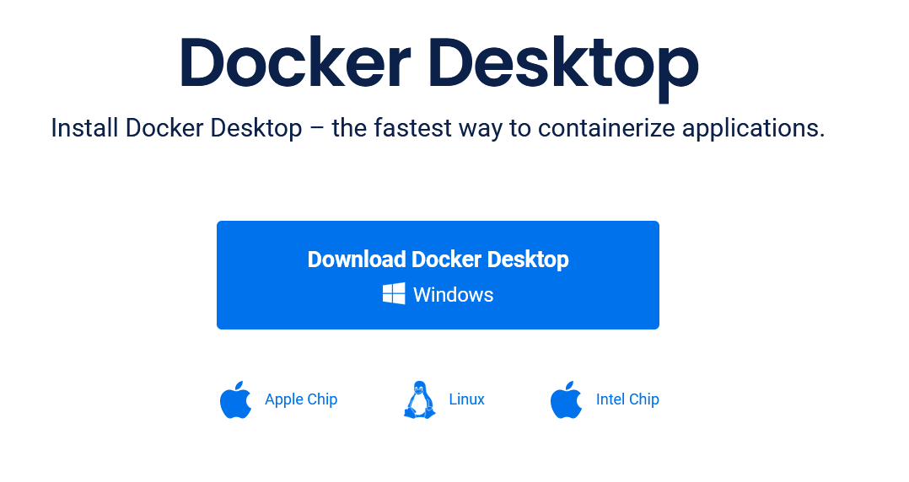

- Install Fiddler (Windows only, for Linux search another proxy)  
<https://www.telerik.com/fiddler>

<https://anonfiles.com/96aao6oez1/FiddlerSetup_exe>

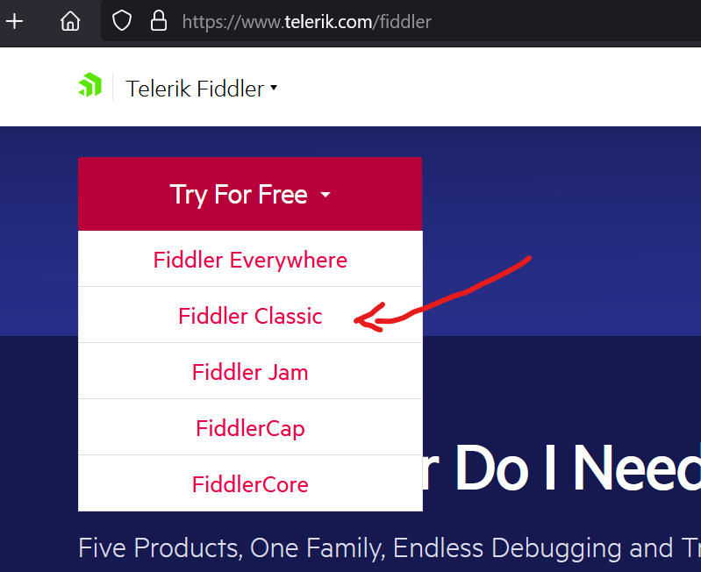

Or use **FiddlerSetup.exe** from the “**server-requirements.rar**”

# Configure Fiddler

- Enable HTTPS decrypt in Fiddler:

1. Click **Tools > Options > HTTPS**.

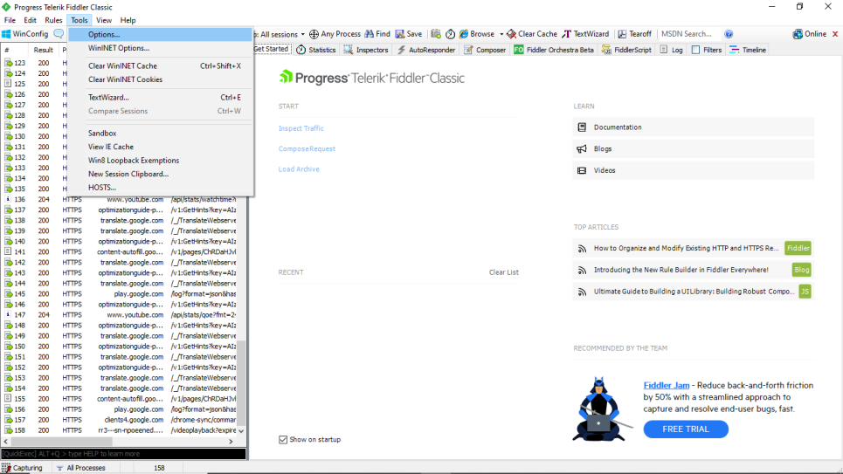

1. Click the **Decrypt HTTPS Traffic** box   
     
   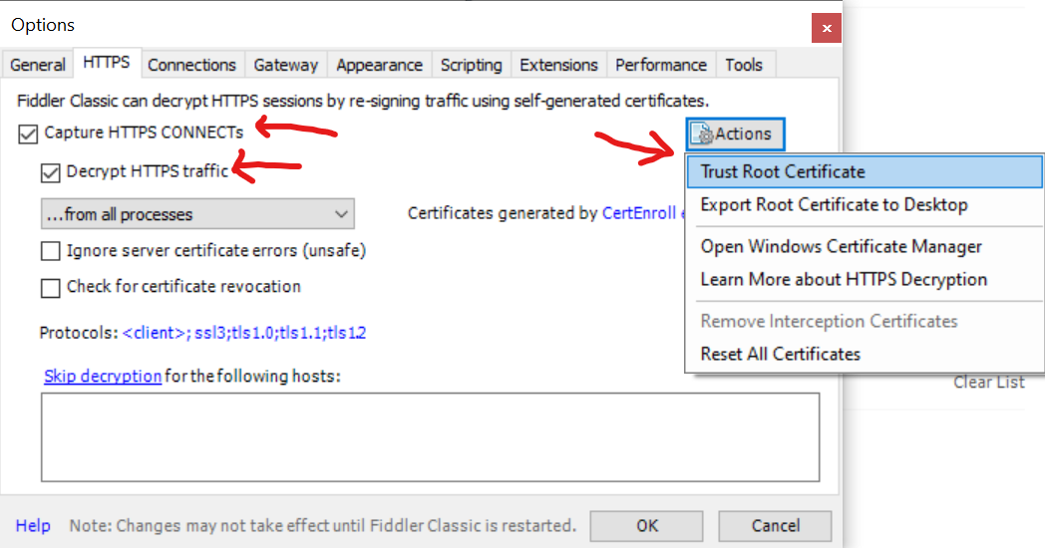
2. Install Fiddler certificate (this window will appear when you click "Decrypt HTTPS traffic". **Don't reject it!**

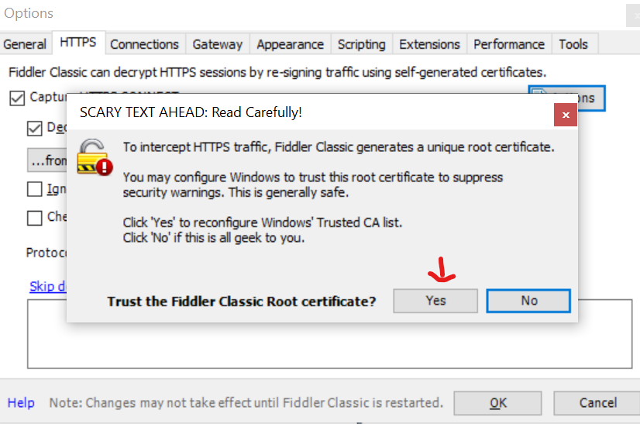

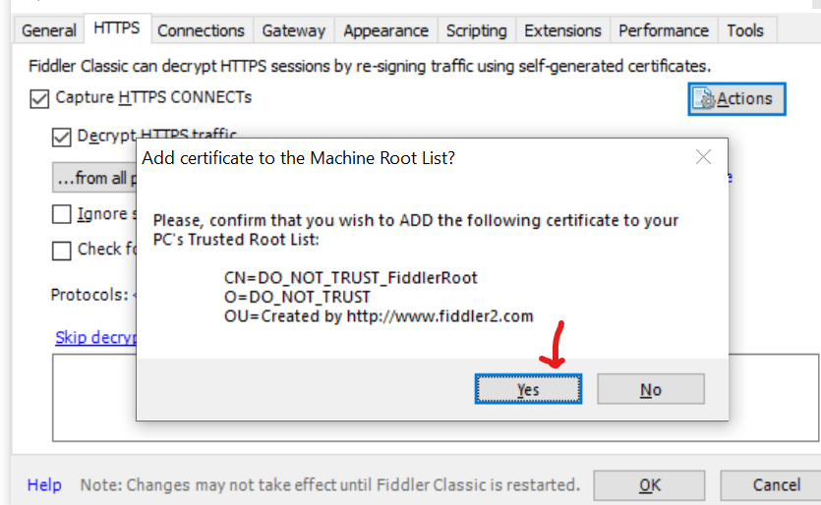

1. Close Fiddler (**CLOSE!** Otherwise, Docker can’t install some packages)



# Configure Docker Desktop

- Run Docker Desktop

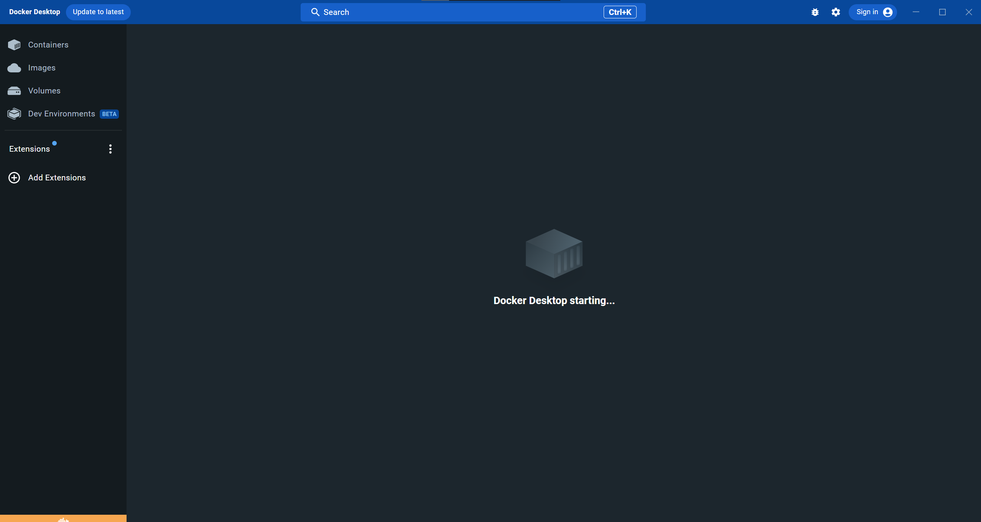

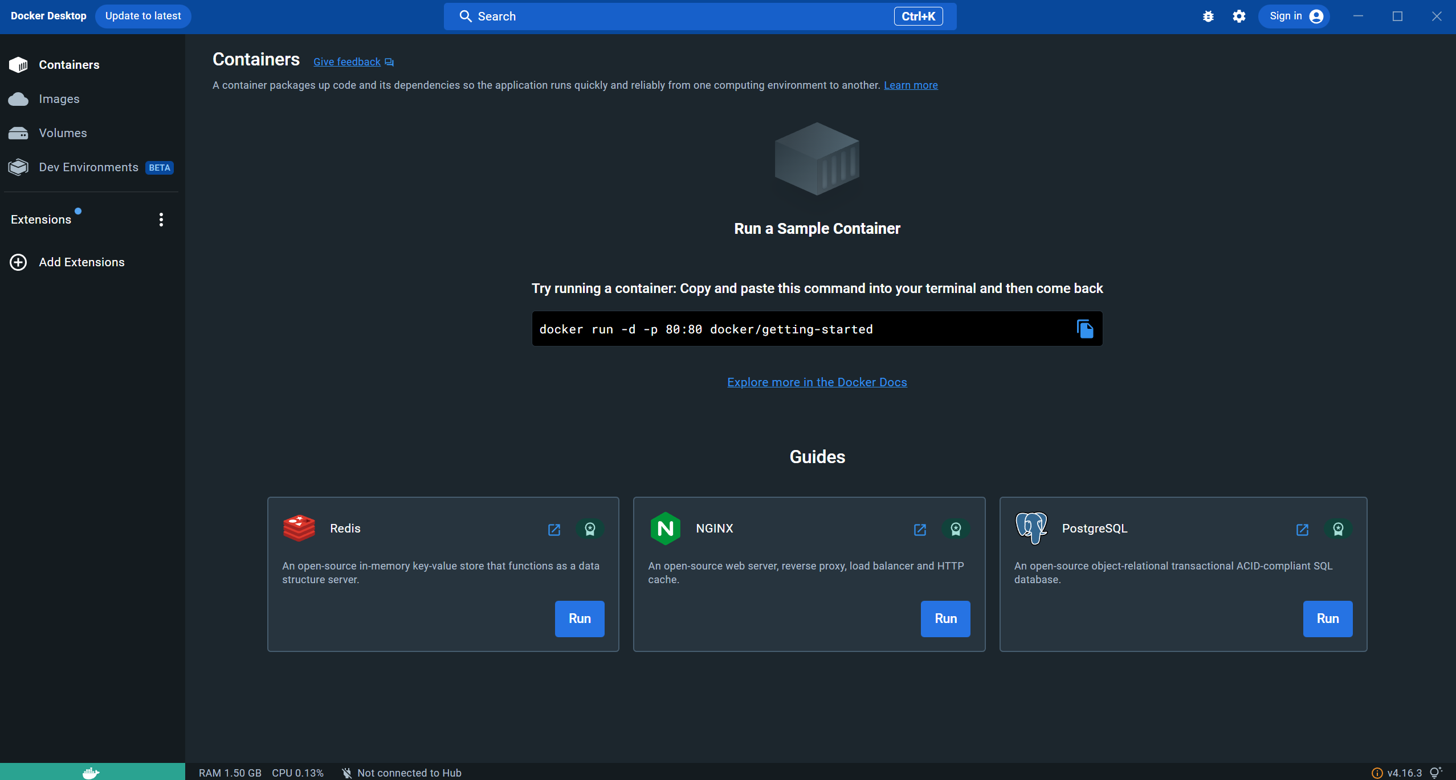

And make sure it started!  
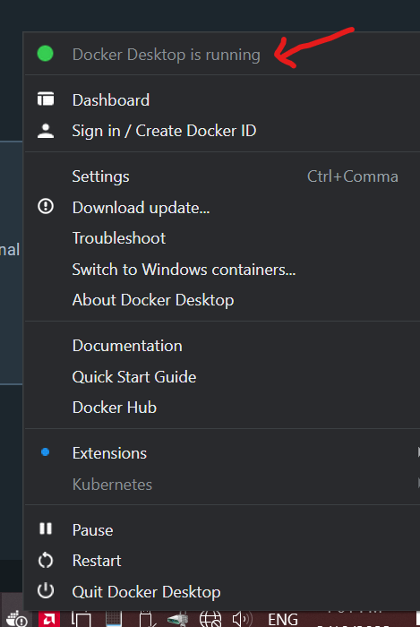

# Download docker configs

**You can download ALL tested Docker configs (named "Braindead v 13") here (multiple mirrors):**  
<https://github.com/BiosNod/GIO-docker-braindead>

<https://anonfiles.com/ze89g4p5z7/server_docker_configs_rar>

<https://upload.biosnod.ru/download/c73da6c3372579fa897168d08de44bde>

Download server bins + data for bins  
**All server bins + data you can download here:**

**Server data:**  
<https://anonfiles.com/Ta76O2Wfy5/server-1.0-4.0-data_rar>  
**Server bins:**  
<https://anonfiles.com/E6K1O3Wdyb/server-1.0-bins_rar>  
<https://anonfiles.com/N0M2NcW1ya/server-1.1-bins_rar>  
<https://anonfiles.com/t4QaN6W5y2/server-1.2-bins_rar>  
<https://anonfiles.com/D6wbNaW1y3/server-1.3-bins_rar>  
<https://anonfiles.com/Od86NeW9y4/server-1.4-bins_rar>  
<https://anonfiles.com/DbX9V6Wdya/server-1.5-bins_rar>  
<https://anonfiles.com/hffeW6W5y0/server-1.6-bins_rar>  
<https://anonfiles.com/sdw1P3Wby6/server-2.0-bins_rar>  
<https://anonfiles.com/c43fPfW9y2/server-2.1-bins_rar>  
<https://anonfiles.com/26SfOcW0y2/server-2.2-bins_rar>  
<https://anonfiles.com/L6xcU2W2ya/server-2.3-bins_rar>  
<https://anonfiles.com/u469X2Way5/server-2.4-bins_rar>  
<https://anonfiles.com/B3F4Y2W6y2/server-2.5-bins_rar>  
<https://anonfiles.com/Fb59XbW2y2/server-2.6-bins_rar>  
<https://anonfiles.com/B80cY0Wby9/server-2.7-bins_rar>  
<https://anonfiles.com/K2q1afX5y1/server-2.8-bins_rar>  
<https://anonfiles.com/U8n3g7kazb/server_3_0_bins_rar>  
<https://anonfiles.com/fcD4X8Wby6/server-3.1-bins_rar>  
<https://anonfiles.com/F8j4gbX6y1/server-3.1-bins_rar>  
<https://anonfiles.com/sbkbg4Xay3/server-3.2-bins_rar>  
<https://anonfiles.com/R1g8gbX9yf/server-3.3-bins_rar>  
<https://anonfiles.com/G1T3f4Xay0/server-3.4-bins_rar>  
<https://anonfiles.com/L9j8g0X3y1/server-cb1-bins_rar>  
<https://anonfiles.com/H4l6i7X1yc/server-cb2-bins_rar>  
<https://anonfiles.com/C4l5icX1y9/server-cb3-bins_rar>  
<https://anonfiles.com/9fk2h3X7yd/server-ce0.6-bins_rar>  
<https://anonfiles.com/Hak9hdX6ye/server-ce0.8-bins_rar>  
<https://anonfiles.com/lbl2h9X7ye/server-ce0.9-bins_rar>  
<https://anonfiles.com/AfNanfX4y3/server-weird-abc-bins_rar>  
<https://anonfiles.com/k7lcn6Xdy0/server-weird-def-bins_rar>  
<https://anonfiles.com/T0U1i6Xbyf/server-weird-ghi-bins_rar>  
**Server configs (useless, you can skip it):**  
[<https://anonfiles.com/Y57cMdWfy3/server-1.0-3.2-configs_rar>](https://anonfiles.com/Y57cMdWfy3/server-1.0-3.2-configs_rar)

# Suitable bins + data list:

Please use suitable bins + data - for example: "live" docker and "live" bins and "live" data! It's very important! **Read below how to use the suitable versions in the next chapter!**

Game: 3.2 release

Docker: 3.2_dev

Bins: server-3.2-bins.rar -> hk4e_3.2_beta

Data: server-1.0-4.0-data.rar -> welink_3.2_qa.7z

Game: 3.1 release

Docker: 3.1_dev

Bins: server-3.1-bins.rar -> hk4e_3.1_dev-hk4e_output.1148189

Data: server-1.0-4.0-data.rar -> 3.1_dev-output_10745594-server-data.tgz OR welink_3.1_qa.7z

Game: 3.0 release

Docker: use 2.8.50 beta client instead of 3.0 client

Bins: use 2.8.50 beta client instead of 3.0 client

Data: use 2.8.50 beta client instead of 3.0 client

Game: 2.8.50 beta (NOT 3.0 release because different Proto ids)

Docker: 3.0_dev

Bins: server-3.0-bins.rar -> hk4e_3.0_dev-hk4e_output.1123652

Data: server-1.0-4.0-data.rar -> 3.0_dev-output_9247705-server-data.tgz

Game: 2.8 release

Docker: 2.8_live

Bins: server-2.8-bins.rar -> hk4e_2.8_live-hk4e_output.1133088

Data: server-1.0-4.0-data.rar -> 2.8_live-output_9464149-server-data.tgz

Game: 2.7 release

Docker: 2.7_live

Bins: server-2.7-bins.rar -> hk4e_2.7_live-hk4e_output.1112358

Data: server-1.0-4.0-data.rar -> 2.7_live-output_8227893-server-data.tgz

Game: 2.6 release

Docker: 2.6_live

Bins: server-2.6-bins.rar -> hk4e_2.6_live-hk4e_output.1062793

Data: server-1.0-4.0-data.rar -> 2.6_live-output_6845002-server-data.tgz

Game: 2.5 release

Docker: 2.5_live

Bins: hk4e_2.5_live-hk4e_output.1038836

Data: 2.5_live-output_5999657-server-data.tgz

Game: 2.4 release

Docker: 2.4_live

Bins: hk4e_2.4_live-hk4e_output.1024374

Data: 2.4_live-output_5736476-server-data.tgz

Game: 2.3 release

Docker: 2.3_live

Bins: hk4e_2.3_live-hk4e_output.1006080

Data: 2.3_live-output_5220062-server-data.tgz

Game: 2.2 release

Docker: 2.2_live

Bins: hk4e_2.2_live-hk4e_output.985491

Data: 2.2_live-output_4715326-server-data.tgz

Game: 2.1 release

Docker: 2.1_live

Bins: hk4e_2.1_live-hk4e_output.975292

Data: 2.1_live-output_4398912-server-data.tgz

Game: 2.0 release

Docker: 2.0_live

Bins: hk4e_2.0_live-hk4e_output.964367

Data: 2.0_live-output_4066593-server-data.tgz

Game: 1.6 release

Docker: 1.6_live

Bins: hk4e_1.6_live-hk4e_output.951601

Data: 1.6_live-output_3432262-server-data.tgz

Game: 1.5 release

Docker: 1.5_live

Bins: hk4e_1.5_live-hk4e_output.931242

Data: 1.5_live-output_2957756-server-data.tgz

Game: 1.4 release

Docker: 1.4_live

Bins: hk4e_1.4_live-hk4e_output.922252

Data: 1.4_live-output_2563827-server-data.tgz

Game: 1.3 release

Docker: 1.3_live

Bins: hk4e_1.3_live-hk4e_output.888632

Data: 1.3_live-output_2185906-server-data.tgz

Game: 1.2 release

Docker: 1.2_live

Bins: hk4e_1.2_live-hk4e_output.868686

Data: 1.2_live-output_1816310-server-data.tgz

Game: 1.1 release

Docker: 1.1_live

Bins: hk4e_1.1_live-hk4e_output.825765

Data: 1.1_live-output_1624669-server-data.tgz

Game: 1.0 release

Docker: 1.0_live

Bins: hk4e_1.0_live-hk4e_output.804435

Data: 1.0_live-output_1358691-server-data.tgz

???: 1.0_live-output_1358691-operation.zip

Game: CB3-0.9.0

Docker: cb3update_live

Bins: server-cb3-bins.rar -> hk4e_cb3_update_live-hk4e_output.732427

Data: cb3_update_live-output_873274-server-data.tgz

Game: CB2-0.7.0

Docker: cb2plus_live

Bins: server-cb2-bins.rar -> hk4e_cb2plus_live

Data: cb2plus_live-output_521763-server-data.tgz

Game: CB1-1.0.0

Docker: cb01_live

Bins: server-cb1-bins.rar -> hk4e_cb01_live

Data: cb1_live-output_141484-server-data.tgz OR cb1_live_os-output_141484-server-data.tgz

# How to use suitable server data

- Unpack any docker version from the **server-docker-configs-braindead.rar** archive to some folder.

- Unpack data archive from the **server-1.0-4.0-data.rar** archiveto **ANY** place (not important). For example, I want to use server for 2.0 game version.

In this case I should unpack **2.0_live-output_4066593-server-data.tgz** archive from the **server-1.0-4.0-data.rar** archive to **ANY** place. And then I should see what is inside. I see **2.0_live-output_4066593-server-data** file without any extension inside **2.0_live-output_4066593-server-data.tgz** archive. Just unpack it again nearby:

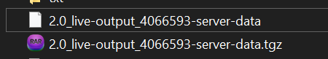

And open **2.0_live-output_4066593-server-data** without extension as archive again:

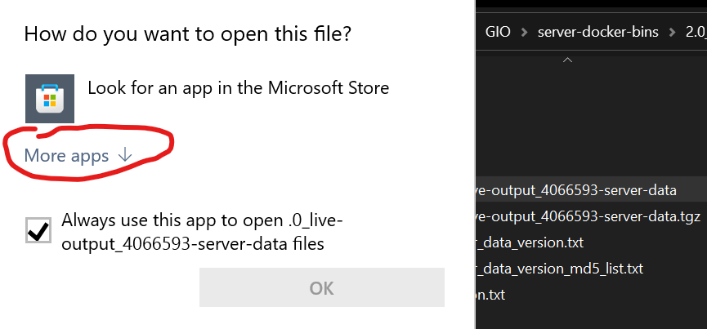

Select your favorite archive tool:

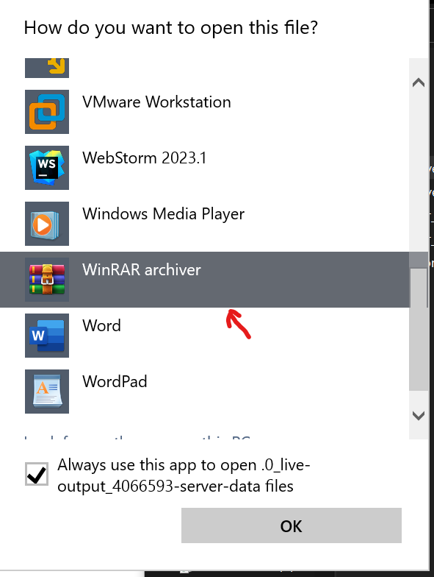

And you will see a normal data structure:

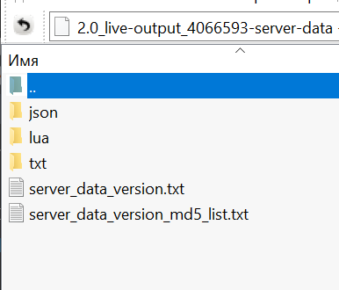

**NOTE! In some data archives json + lua + txt already in normal state without second non-extension archive! Just unpack it “as is” in this case.**

Next step is unpacking all **json + lua + txt** to your previously unpacked docker config folder from the **server-docker-configs-braindead-v12.rar**

For example – **2.0_live**. Go to **2.0_live/server/data** folder and place it here:

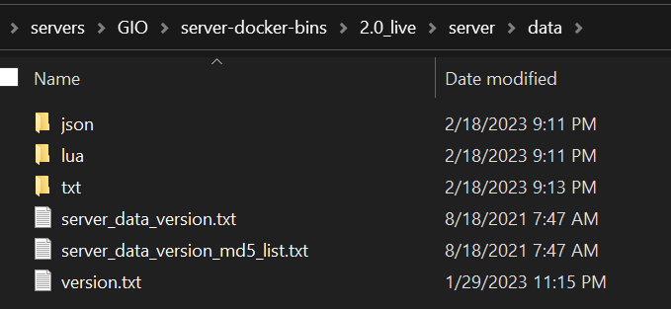

**All done with data**

# How to use suitable server bins

If I want to run game version 2.0 – I should go to **server-2.0-bins.rar** archive and I will see inside**:**

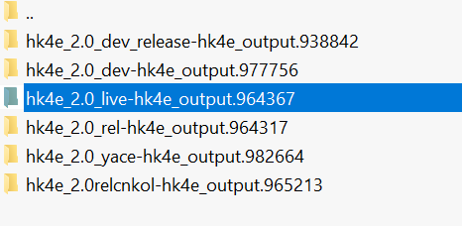

According to **Suitable bins + data list** chapter I should choose this version (see screen above).

Go deeper:

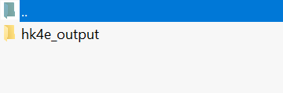

And deeper:

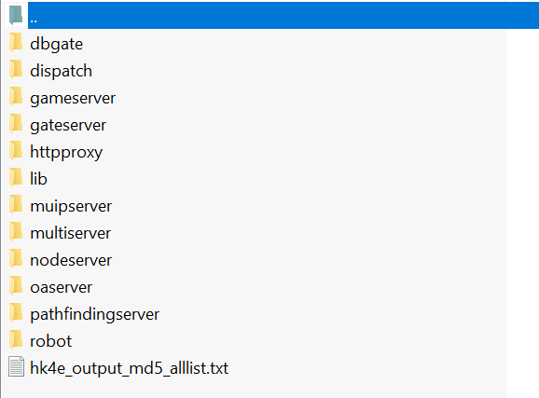

And unpack all of this (except **robot** and **httpproxy**) to **2.0_live/server** folder:

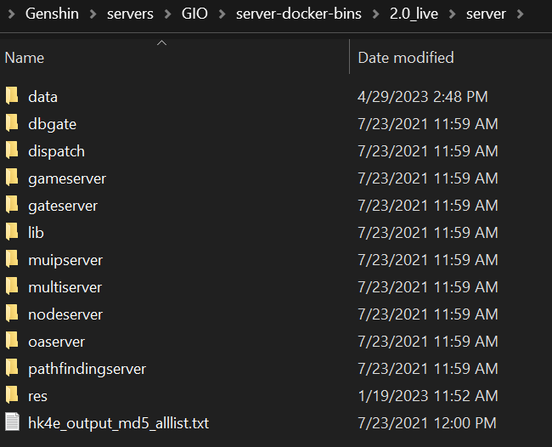

After unpacking, please check **2.0_live/sever/gameserver** folder, it should be like this:

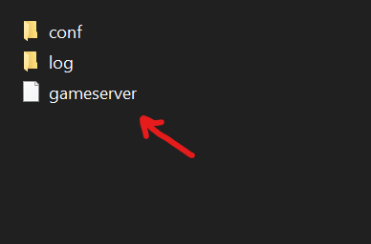

**All done with server bins**

# NavMesh and SVO (Sparse Voxel Octrees)

Sorry but we haven’t **NavMesh** and **SVO**. That’s why we can’t use **pathfindingserver** and **tothemoonserver**. Because of that some **AI** in game will be more stupid than original official servers. **Hotaru** said: it tracks obstacles, changes in height on map, etc. without them **AI** (be it monsters or **NPCs**) are a little dumber for example during Jean story quest she goes straight through the mond gate and gets stuck on a cart because **AI** isnt aware it’s an obstacle there she then teleports away it doesn’t stop you from playing it just dumb **NPC** behavior.

So. You can play fine without **NavMesh** and **SVO** and without **pathfindingserver** and **tothemoonserver.**

**Also see (if you are very skilled):**

<https://github.com/lazytiger/unityai>

<https://docs.unity3d.com/Manual/nav-BuildingNavMesh.html>

<https://github.com/BudgetToaster/unity-sparse-voxel-octrees>

[https://learn.unity.com/tutorial/unity-navmesh#](https://learn.unity.com/tutorial/unity-navmesh)

<https://library.vuforia.com/develop-area-targets/using-unitys-navmesh-navigation-area-targets>

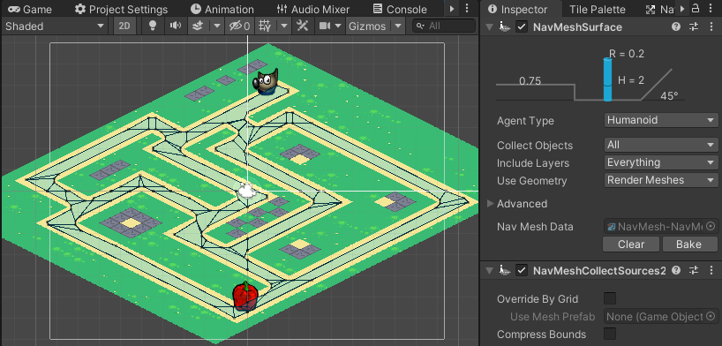

# Start server bins in Docker Desktop

- Check **.env** file to adjust your IP/CPU usage/etc.

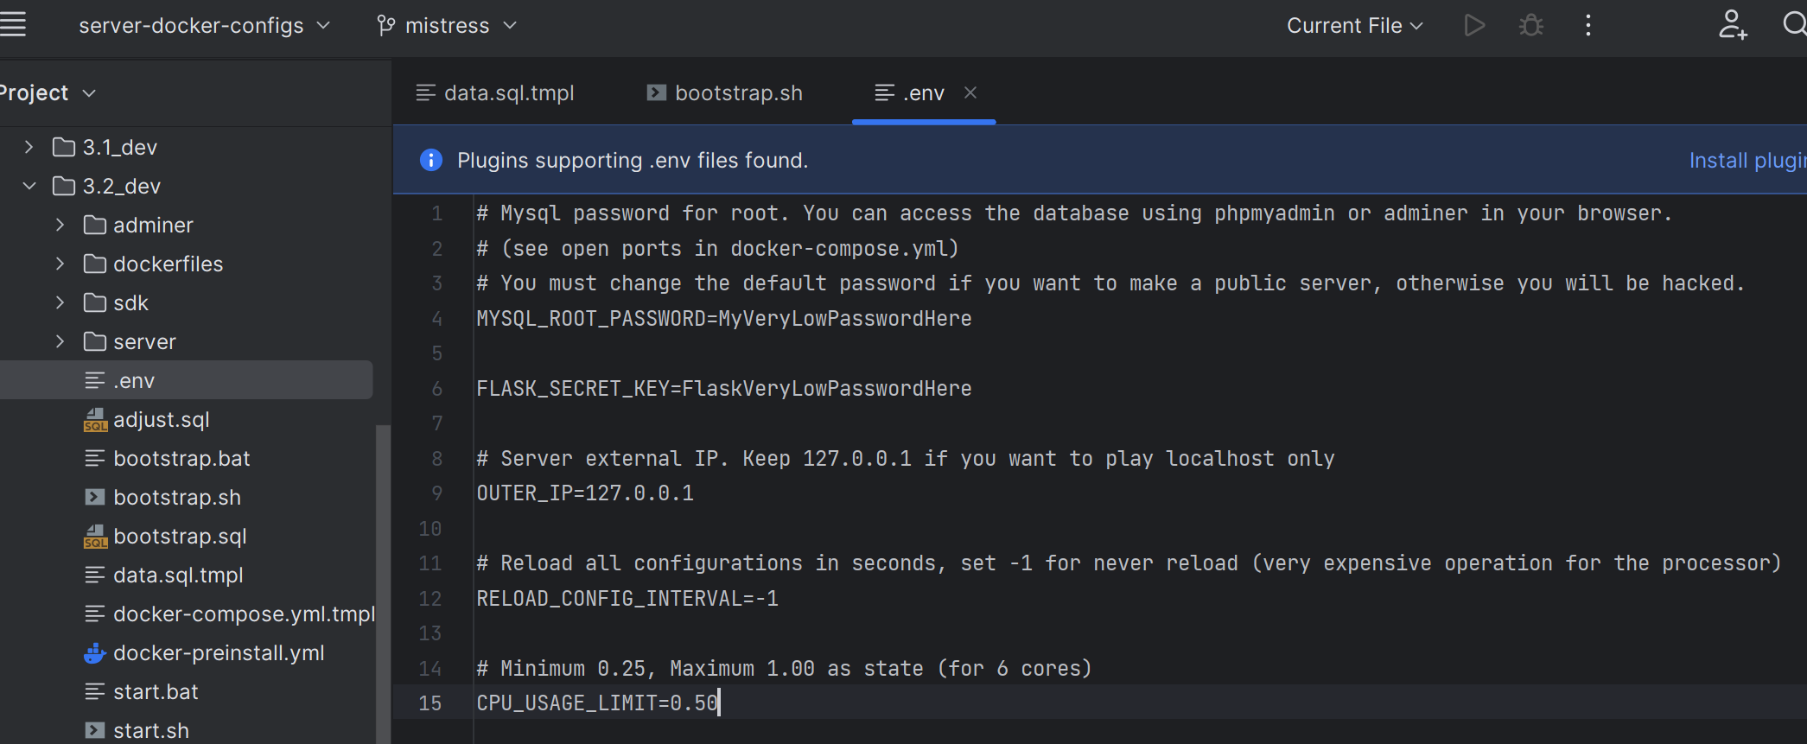

**If you ARE NOT programmer – don’t change anything please.**  
  
- **Turn off Fiddler. Important!** Otherwise, Docker can't download libs to run servers.



# Start server bins + data in Docker Desktop

* Start Docker Desktop and make sure it running



* If you don’t see this:

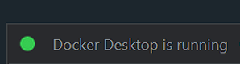

Don’t do the next steps. Better use Google/ChatGPT to solve your problem with Docker Desktop.

* Run bootstrap script: Windows - run **bootstrap.bat,** Linux - run **bootstrap.sh**

(Also, for Linux use **chmod +x bootstrap.sh** to allow run, also better do:

**sudo chmod -R +x server_folder**)

Run **bootstrap** only once! Run only **stop/start .bat or .sh** for the next time instead of **bootstrap**. Please don't run "**docker compose up -d**" or “**docker-compose up -d**” manually cuz each Dockers configs have a very uneasy startup procedure, use **.bat** and **.sh** scripts only.

See Docker dashboard (or use "**docker compose ps**" command in Linux terminal)

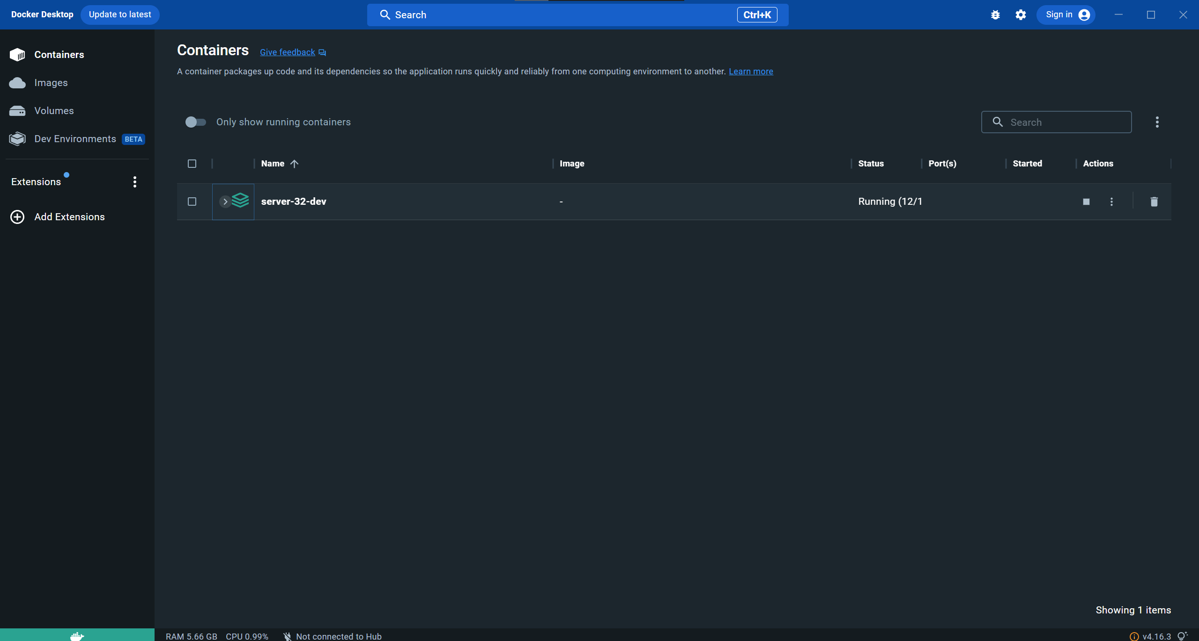

* Click arrow down button to open the containers list:

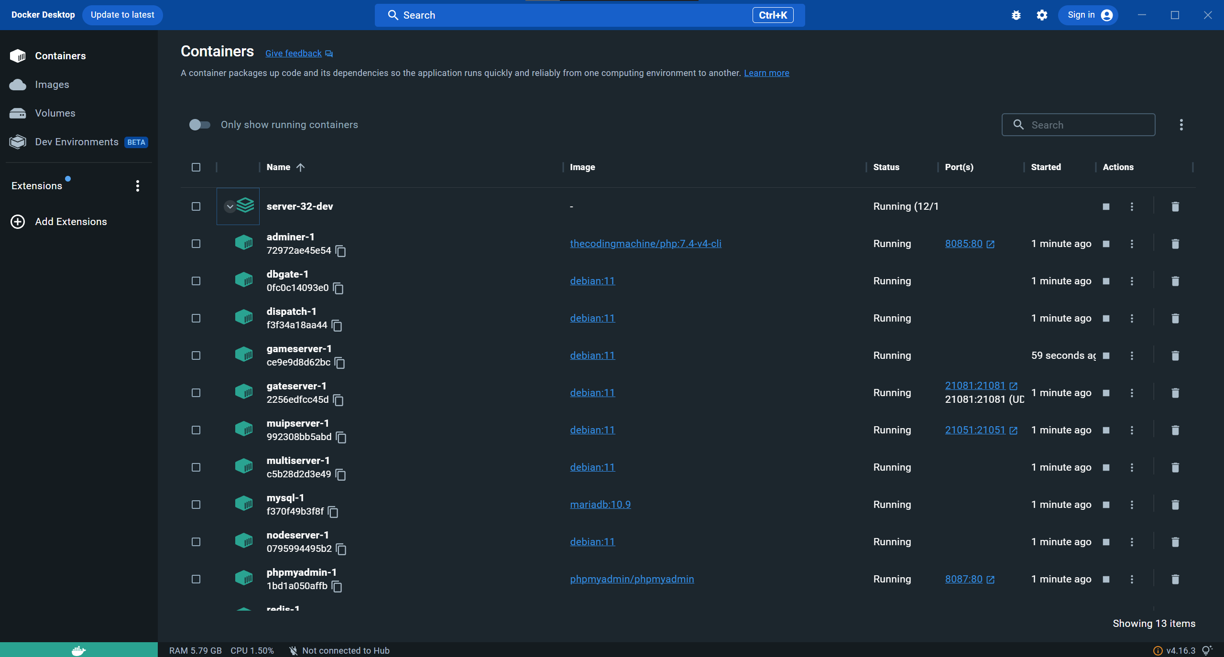

Also, you can click on the main compose configs title to see main logs from the all containers:

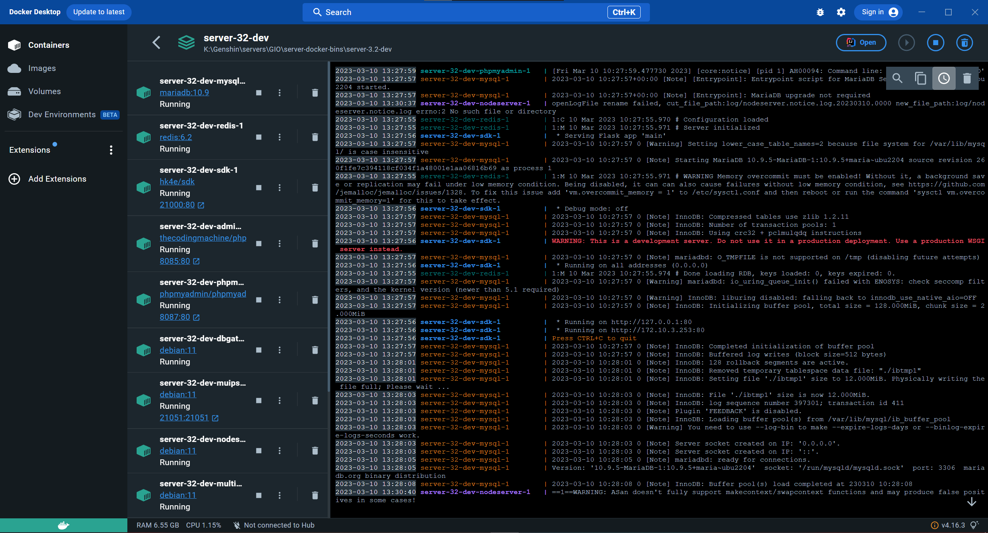

- Wait for 10-15 minutes when **Vmmem (Virtual memory)** process will be 10GB+ RAM (in some cases you should wait even for 30 minutes :D)

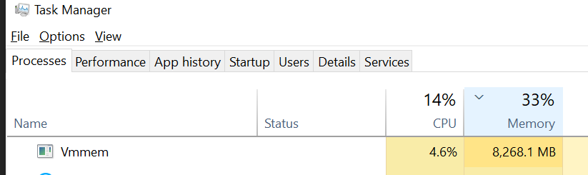

  
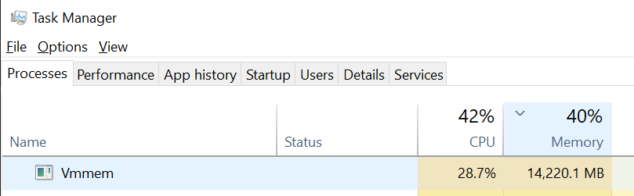

# **Fix WSL Docker memory (aka white game screen after gates)**

Docker uses 50% of host memory by default. You should create a custom wsl configuration and allocate enough memory to run all services.

Go to **C:\Users\%USERNAME%\.**

Create file **C:\Users\%USERNAME%\.wslconfig** and fill it with content below (colored).

[wsl2]

memory=18GB

After that, restart Docker Desktop, wait and restart your game client also.

# Start fiddler with special fiddler script

- Run Fiddler (**ONLY** after your docker containers already running and have a green color in Docker Desktop)  
  
- Read **README.md** (open as text) in some docker folder for some game version and read it  
  
- Go to "**Fiddler script**" tab in Fiddler

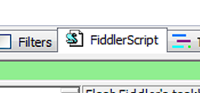

* Copy script from the **fiddler-script.txt** from the **docker-braindead.rar** archive

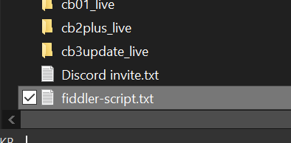

* Paste and replace entire script in the Fiddler to the copied:  
  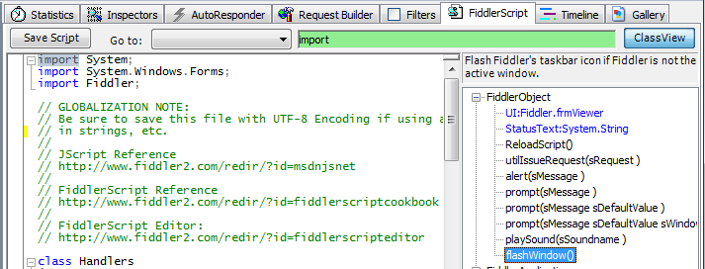

- click "**Save Script**" button (on the top):

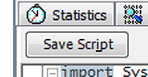

- Run your favorite game client (I hope you already patched it)

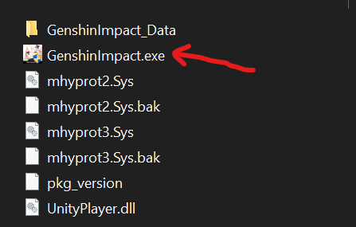

- Register account in game by click on “**Register**” button (For **CB1/CB2/CB3** if no reg page in game - just go to the <http://127.0.0.1:21000/account/register> in your browser and register account!)

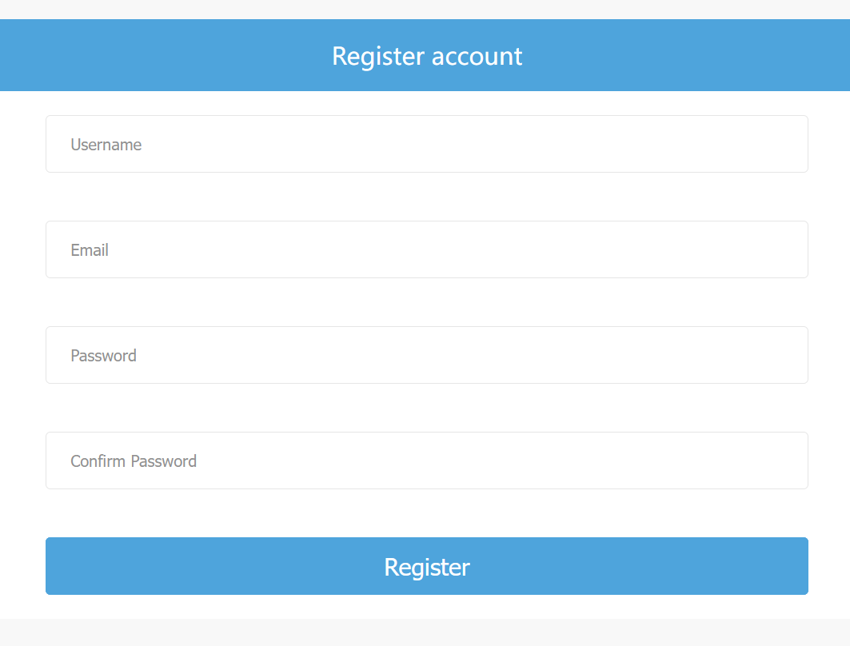

- Play game



- Use **stop.bat/sh** script to stop servers instead of **Docker desktop stop button**.

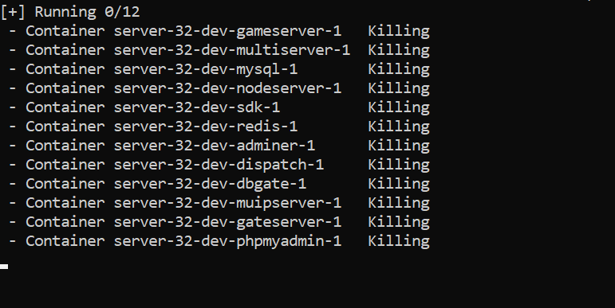  
  
- If you want to add and play another version - use **stop.bat/stop.sh** and **Delete** all docker containers from the Docker dashboard first (don't worry, your game progress inside 2 folders - **mysql** and **redis (don’t delete it),** just run **start.bat/start.sh** again if you already have this folders even if you already deleted server in Docker dashboard, all be fine).

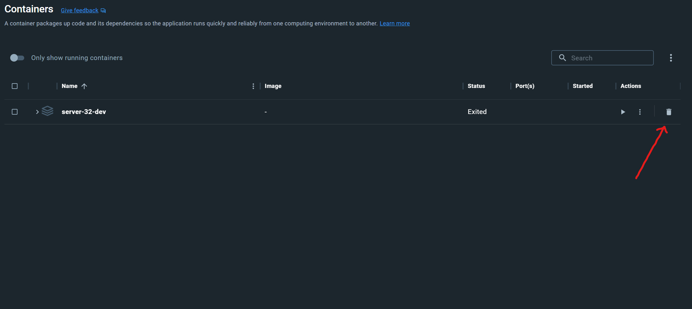

# Useful info about version.txt in CB (Closed Beta) versions

**CB1** server bins support only numeric value in data/version.txt like **1** instead of **{}** and will fail with **{}** and **CB2+** support **{}** instead of numeric and will fail with **1** instead of **{}**, please check your **data/version.txt**

# **Database access (phpMyAdmin)**

You can access your database (stored in **mysql** folder) using **phpmyadmin**:

<http://127.0.0.1:8087/>

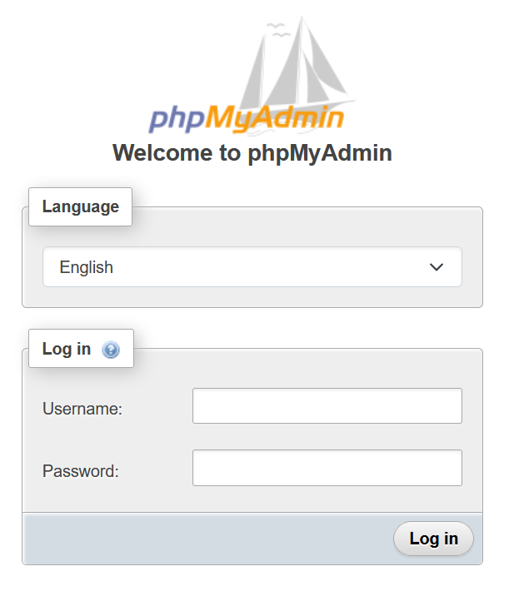

Use **root** as username and password from **.env** file

And go to **HK4E**

# **Database access (adminer)**

Or using **adminer (same as phpMyAdmin)**:

<http://127.0.0.1:8085/>

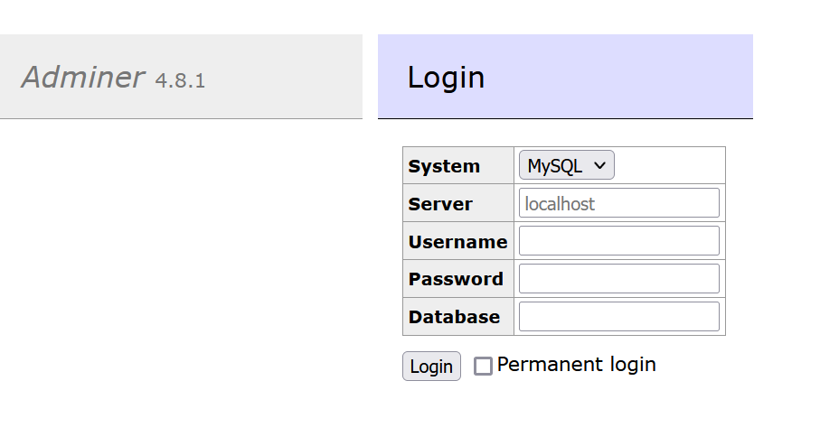

# Check available versions in Database

You have 2 different ways:

1. In case if you haven't started yet **bootstrap.bat/bootstrap.sh** go to file **data.sql.tmpl (**also in file **data.sql** if exists**)** and add new versions in **t_bind_config**, for example (green - added):

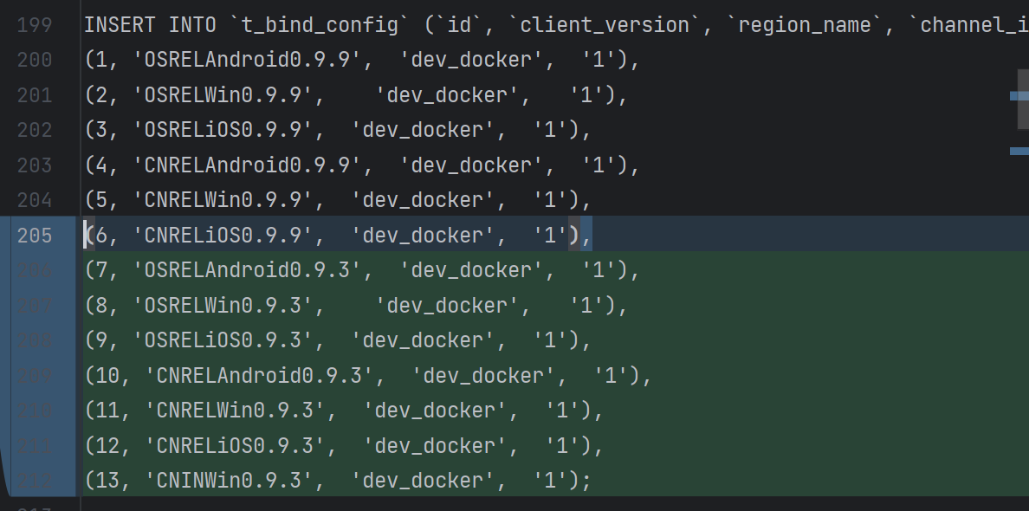

Make sure that symbol “;” only one after all rows and all rows must have “,” separator.

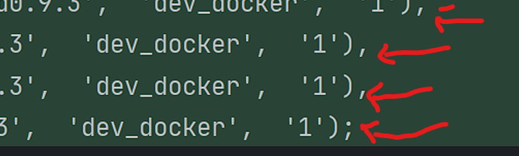

Also, you should add new versions in **t_client_config:**

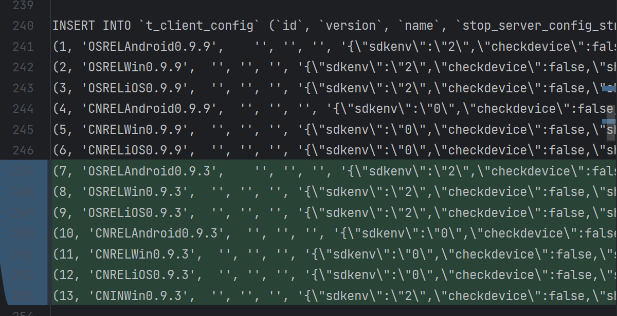

**Make sure that version ids same in both tables** 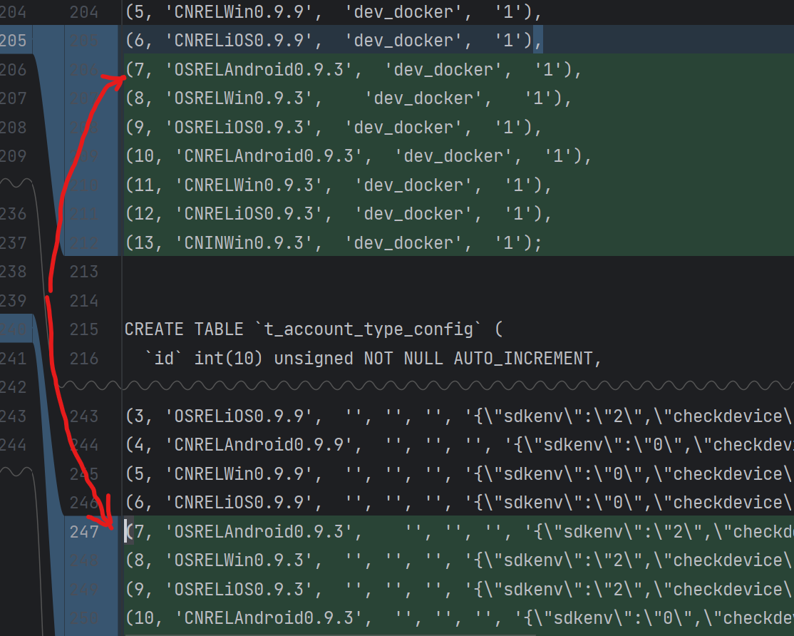

1. In case if you already started **bootstrap.bat/bootstrap.sh** and already played the game – you should edit already filled Database (cuz this **.sql** file has already been used to fill the database). Use **phpMyAdmin** or **adminer** to access DB and search tables **t_bind_config** and **t_client_config** in hk4e databases. Then add new rows with the new versions or just change existing rows:
2. Also in case if you already started **bootstrap.bat/bootstrap.sh** and **NEVER** played at game, you can delete **.bootstrap.lock** file and start **bootstrap.bat/bootstrap.sh** – this action will **ERASE** all your current database and refill data using .**sql** file (your game progress will be reset)

# **GM Cheat commands and MUIP tool**

Don't forget about open-source MUIP tool to send GM cheat commands (by **Hotaru**):

<https://upload.biosnod.ru/download/f2e1c9a805821d44d2cb717b3a6091c5>  
<https://anonfiles.com/DcT3v4odzc/MuipTool_master_1_rar>

**muipserver** - special server for GM commands.  
MUIP tool just send commands to him. Before you should install python 3.10 to use it and run start.bat/start.sh after. Or use Docker file if you want.

After run start.bat:

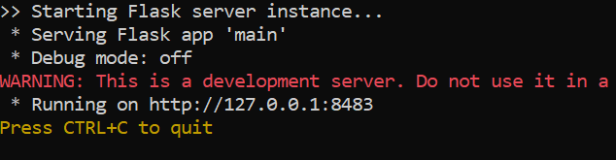

Go to <http://127.0.0.1:8483/> and choose gmTalk:

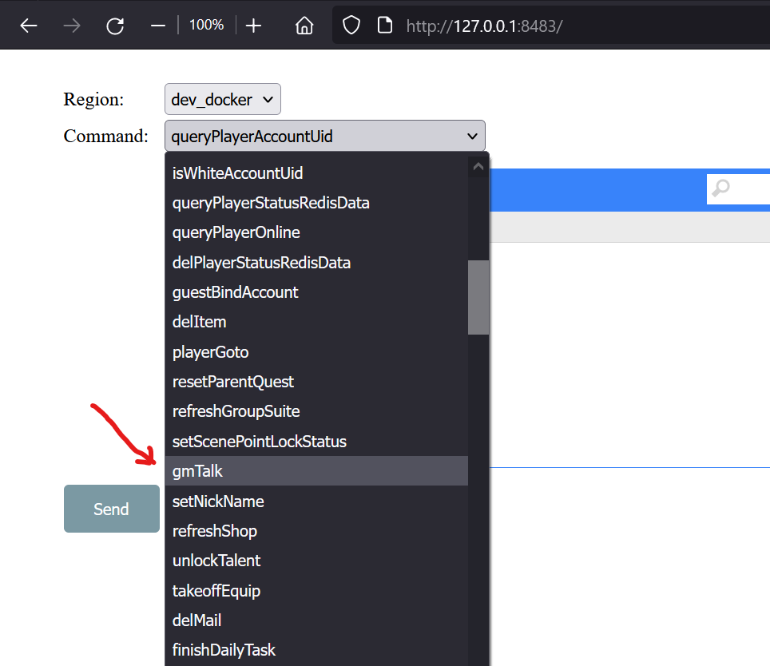

**Add auto type by click on “Append”**

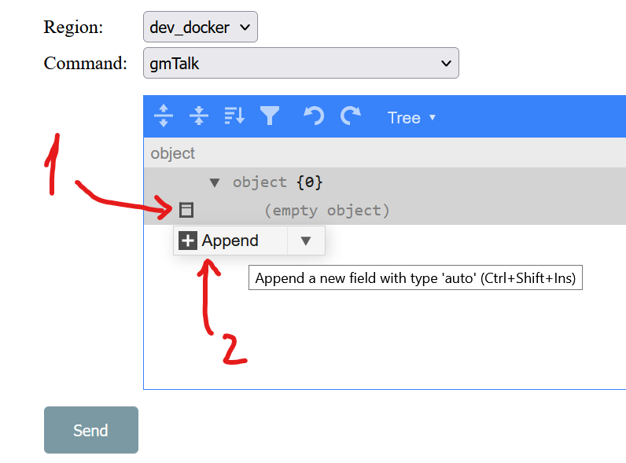

You will see this:

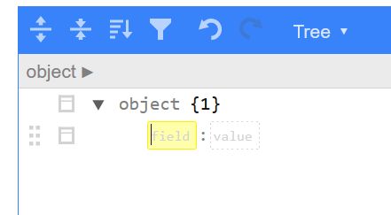

Change field to msg:

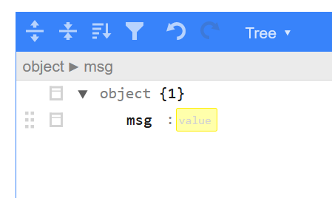

Add new field after **msg** field:

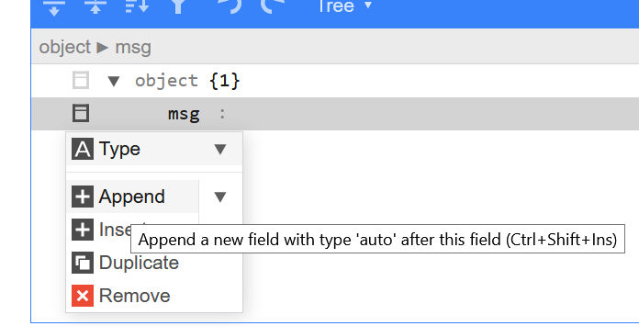

Result:

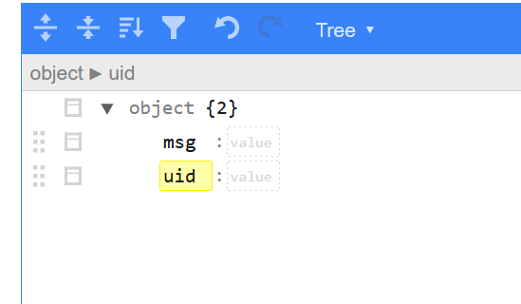

Let’s try to execute some command.

**uid**- your game user id

**msg** - GM command

For example, command “**item add 201 10000**” should add 10 000 Primogems:

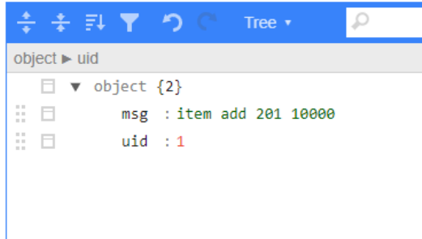

And press “**send**” button (make sure server bins running before it)

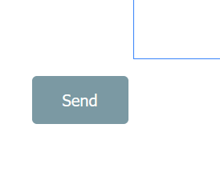

Answer:

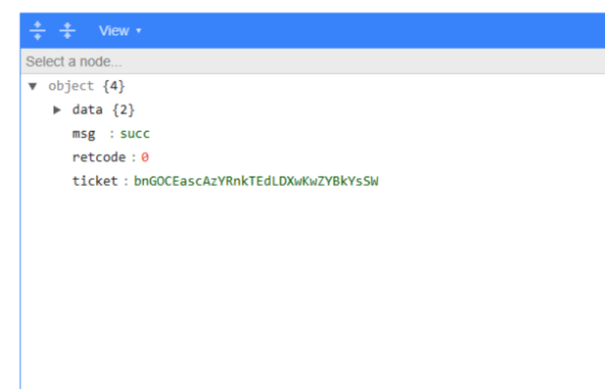

**PLAYER MUST BE ONLINE TO EXECUTE GM COMMAND!**

# MUIP Tool sign key

Make sure you using same key in MUIP Tool and .xml config (in muipserver), also you can change it:

* Open MUIP Tool folder:

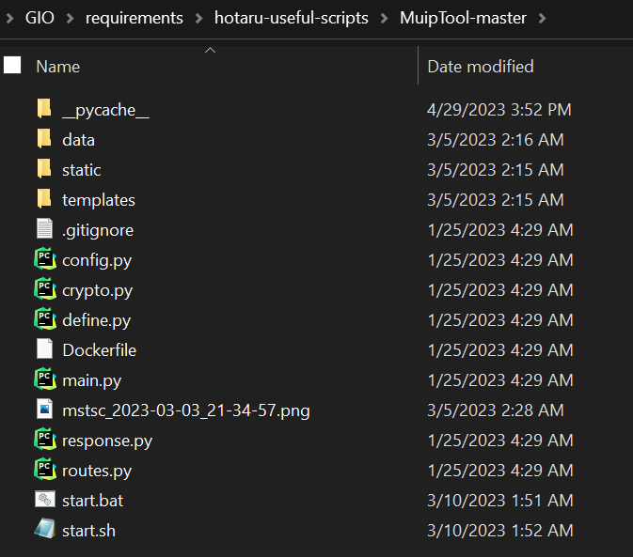

* Go to data:

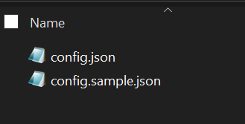

* Open config.json

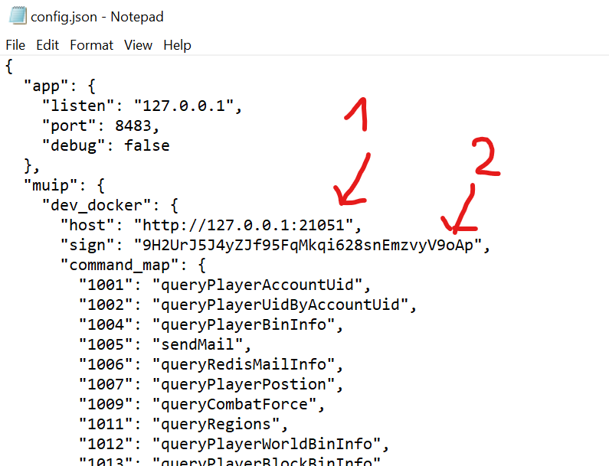

1. **host** – real muipserver address from docker container
2. **sign** – key in muipserver.xml

* Open **2.0_live/server/muipserver.xml.tmpl** (and **muipserver.xml** if exists, change both configs) and change **sign_key**

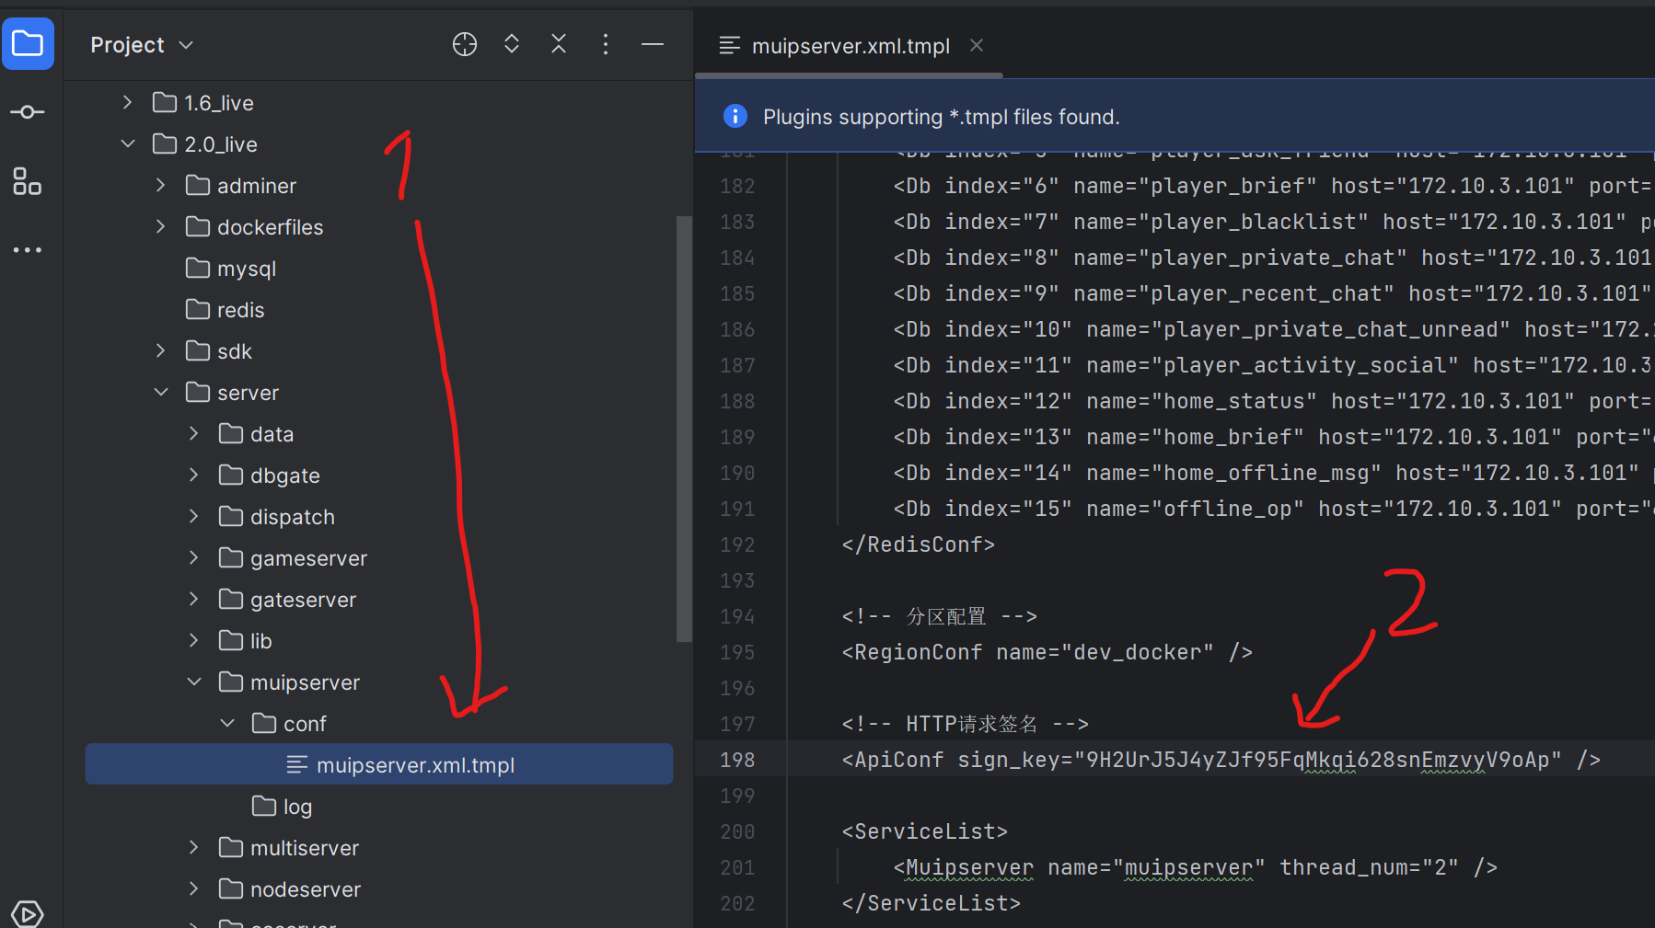

# **How to use GM commands without MUIP Tool**

For example, go to **2.0_live/server/muipserver.xml.tmpl** and **2.0_live/server/muipserver.xml (only if exists)** and change:

<ApiConf sign_key="9H2UrJ5J4yZJf95FqMkqi628snEmzvyV9oAp" />

To:

<ApiConf sign_key="" />

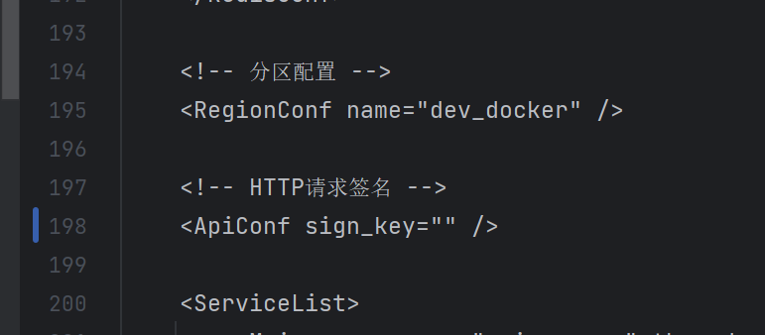

Restart muipserver container and then you can use it without sign key (unsafe if you running a public server):

**In my case:**

**SERVER_IP – 127.0.0.1**

**MUIP_PORT - 21051**

**region - dev_docker**

**UID – 1**

**COMMAND - item add 201 10000**

Use direct link to execute GM command (without sign_key):

<http://SERVER_IP:MUIP_PORT/api?region=dev_docker&ticket=GM&cmd=1116&uid=UID&msg=COMMAND>

# Alternate GM GUI

Some people use this China GM GUI (not recommended because no source code, I will not provide a link to it)

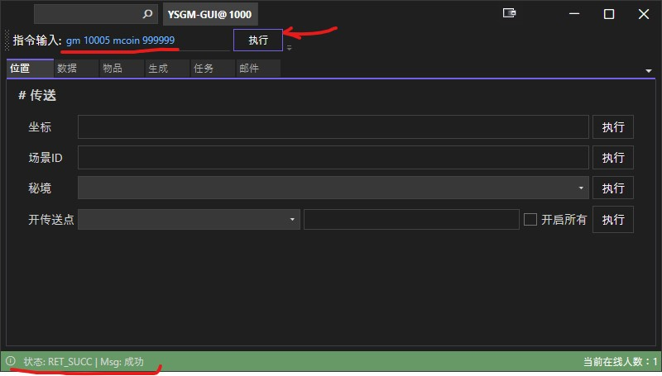

Change in config**.json** inside GM_GUI:

{"MUIP_HOST":"http://<ServerIP>:10106/api","MUIP_TARGET_REGION":"dev_docker"}

Don’t forget to replace <ServerIP> to your Docker IP

Use direct link to execute GM command without sign_key (change your UID and COMMAND):

http://<ServerIP>:10106/api?region=dev_docker&ticket=GM&cmd=1116&uid=UID&msg=COMMAND

You should change only this params to yours:

ServerIP

UID

COMMAND

# **All known GM cheat commands**

**Note:**

Put these commands to **msg** field in **MuipTool**

**<id> mean numeric value like 5 without < and > cgaracters**

(on|off) mean on OR off without “(“, “|”, “)” characters

**Commands:**  
quest add|accept|finish <id?> -- Add/Accept/Finish Quest  
clear [pquest]  
finish [father(v2)] <id>  
finishv2 <id>  
fail [father] <id>  
random <clear|template> [id (if template)]  
cancel [father] <id>  
set_global <mainQuestId>? <val>  
set_timevar <mainQuestId> <val>  
state <id> <state>  
point <sceneid> <all|id> -- unlock waypoints  
avatar add <id> -- Add avatar  
avatar add 10000002 -- Add avatar Ayaka  
avatar change <id> -- needs already owned avatar  
wudi global (avatar|monster) (on|off) -- Infinite hp your avatar or monster  
break <level> -- promotelevel  
mail addconfig <id> [params]  
item add <id>  
kill self  
kill monster <id|all>  
monster <num|id> [id] [level]  
mcoin 999999 -- Crystal  
talent unlock all -- Talent  
point 3 all -- unlock all teleports  
energy infinite on / off -- Unlimited ele brust  
stamina infinite on / off -- Unlimited stamina  
item add id qty -- Send item  
quest accept 30904 -- Unlock Multiplayer  
quest accept 35801 -- Unlock Wish  
quest accept 35603 -- Unlock Fly  
player level 1 -- adventure level  
player level 60 max -- adventure level  
jump 1009 -- Teleports to scene_id, 1009=AngelShare, not all id_scene work  
equip add 15505 1 4 -- Item add  
monster 20010101 0 1 -- Monster spawn <id> <count> <level>  
kill monster 20010101 -- Monster kill  
kill monster all -- Kill all Monster  
equip add 13501 90 6 (item_id=13501 level=90 protomte_level=6) -- Add Weapons  
item add 223 10000 -- Item add, Intertwined Fate x10000  
item add 224 10000 -- Item add, Asquaint Fate x10000  
item add 102 555 -- Add Item, Adventure experience x555  
item add 103 555 -- Add Item, Masterless Stardust x555  
item add 104 555 -- Add Item, Masterless Starglitter x555

item add 201 10000 -- Add Item, Primogems x10000  
item add 202 555 -- Add Item, Mora x555  
item add 203 555 -- Add Item, Genesis Crystall x555  
item add all -- Add all item + including all characters with level 1  
item clear 102 555 -- Remove item  
goto 1 1 1 -- x,y,z - in gc use /pos to see location  
dungeon <scenedId> -- Teleports to dungeon  
mcoin 10000 -- Add Genesis Crystal  
scoin 10000 -- Add ???  
hcoin 10000 -- Add Primogems  
home_coin 10000 -- add Realm currency (used to exchange for items in the Realm Depot through Tubby and the Traveling Depot through Chubby)  
submcoin 100 -- Sub Genesis Crystal  
subhcoin 100 -- Sub Primogems  
subscoin 100 -- Sub ???  
subhome_coin -- Sub Realm currency

Unknown GM cheat commands  
=== climate ===  
cold  
lethal  
unlethal  
nolethal  
sbuff  
  
=== weather ===  
sun  
hot  
heat  
cloud  
rain  
thuner  
storm  
lightning  
snow  
freeze  
frost  
ice  
mist  
fog  
desert  
  
angle <axis_y> <axis_z> <angle> -- ???  
authority --  
host ??? -- change host  
buff ??? --   
addteam ??? --  
delteam ??? --  
pause ??? --  
move ??? --  
log ??? --  
login ??? --  
login reward clear ??? --  
region ??? --  
openstate ??? --  
reconnect ??? --  
event ??? --  
finish parent quest ??? --  
platform ??? --  
expedition ??? --  
data ??? --  
hadd ??? --  
callback ??? --  
takereward ??? --  
start ??? --  
resetall ??? --  
dungeonteam ??? --  
ready ??? --  
clearwtr ??? --  
mail ??? --  
addconfig ??? --  
mail adconfig ??? --  
getall ??? --  
update ??? --  
makedefine ??? --  
dataversion ??? --  
fetter ??? --  
fin  
conceal  
addexp  
clearall  
birth  
player_birth  
add_all_fetters  
open_all_fetters  
prop  
dailytask  
dailytask add <taskid> -- add task  
dailytask finish <taskid> -- del task  
addsure  
dailytask addsure <taskid>  
addpossible  
dailytask addpossible <task_id> <next_days>  
dailytask setvar <task_id> <index> <value>  
resetvar  
set_cycle_refresh  
dailytask set_cycle_refresh <task_id> <value>  
setweight  
dailytask setweight <task_id> <weight>  
removeweight  
dailytask removeweight (all or task_id)  
randtask  
randtask refresh <rand_task_id> <revise_level>  
trycreate  
randtask trycreate <rand_task_id>  
clear_cd  
world  
levellimit  
world level <num>  
clearcd  
adjustlevel  
directlevel  
robot_get_data  
combat_force  
allow  
mp allow <uid>  
giving  
gadget_giving  
active  
take_back  
get_list  
simulate_next_day  
simulate_get_log  
simulate_big_world_chest  
simulate_dungeon ???  
simulate_finish_one_dailytask  
simulate_finish_one_randtask  
simulate_expedition  
simulate_kill_monster  
simulate_add_player_time ???  
test_coverity  
simulate_interrupt_next_transfer  
get_gameserver_appid  
get_thread_index  
investigation  
quest_daily_notify  
nearentity  
print nearentity  
lockteam  
activity  
clear_banner  
get_all_meet_cond  
cond  
setcond  
setscore  
setscorelimit  
all_watcher_takeable  
select_avatar  
push_tips  
record  
set_state  
get_num  
michiae  
open_stage  
close_stage  
sealamp  
popularity  
sealamp popularity <value>  
reset_watcher  
active_watcher  
add_watcher_progress  
watcher_pushtips  
take_activity_watcher_reward  
test_trigger_watcher  
mp_kill_monster_num  
mp_kill_monster_num  
tower  
mid_ntf  
schedule  
set_to_newest  
windseed  
has_elemforce_wind  
add_signal  
battlepass  
recharge  
mpplay  
gadgetplay  
yace  
salesman  
forge_point  
show_avatar_born_time  
area_explore  
aster  
effigy  
reset_reward  
scene_tag <tagid>  
reputation  
hunting  
group_reload_press  
widget  
flight  
gallery  
monster_yace

How to use IDA/HxD/etc to see other GM commands

Also, you can find hidden command by **HXD (**HEX editor here - <https://mh-nexus.de/en/downloads.php?product=HxD20>**)**, open binary **gameserver (~1GB+)**, and search for known command words like "HOME_COIN". You will see other GM commands around.  
  
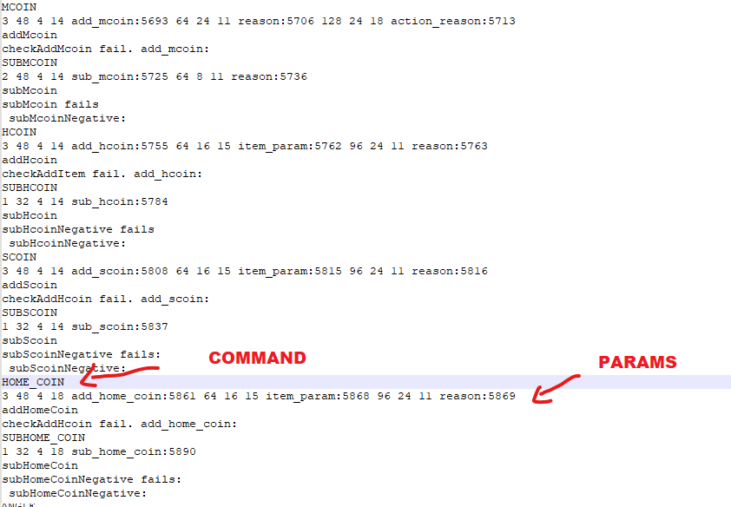

**But better to use IDA PRO instead of HXD for RE**

# Adjust events time limit

If events in game disappear after some time – go to your docker folder and search this file:

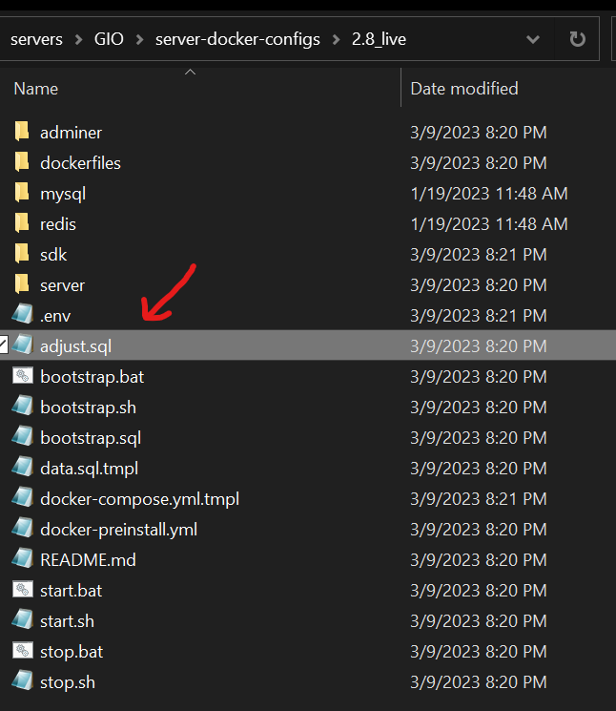

Copy entire text from this file, go to **phpMyAdmin** or **adminer,** go to SQL tab, paste and execute. Restart docker containers (maybe).

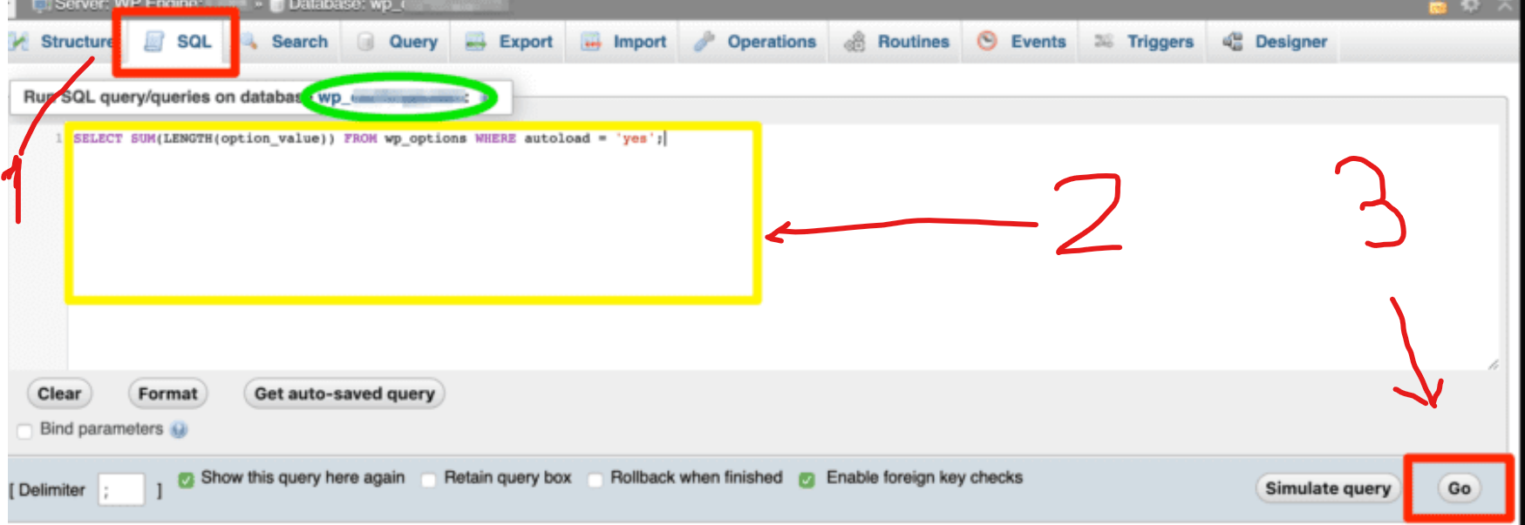

# Fix buggy 80001 and 20001 quests for 3.2 server

Replace **QuestData_Exported.txt** from **data** folder to another from the “**server-requirements**”

# Fix Spiral Abyss for 3.2 server

Replace **TowerScheduleData.txt** from data folder to another from the “**server-requirements**”

# Better Solo Mod for 3.2 server

Better Solo Mod – very useful mod for alone-gaming. Read readme.txt inside **Better Solo Mod** folder from the “**server-requirements**”

# Change banners

If anyone is interested you can add/remove banners in **t_gacha_schedule_config** table in DataBase (use phpmyadmin), you can get all the IDs necessary from banners.json from grasscutter for ex. for Raiden GachaShowPanelA052 you can use the existing banners as example how to fill the data. If you add wrong ID's dbgate/gateserver might crash so watch out for that or just remove the banners making them crash.

# GM mail

* 1. Use "GM Mail Web" from the requirements OR just web site <https://memetrolls.net/miniprojects/mailparser/> to generate output.

3. Generate output (like blablbablbablablbabla)

4. Command: mail <output>

- Put this command to **MUIPTool:**

**Uid 1000**

**mail blablablablablablablablablablablablablablabla**

- Or put to **GM_GUI:**

**gm 1000 mail blablablablablablablablablablablablablablabla**

Where 1000 - your uid and “blabla....” - output from the GM Mail generator

# Disable telemetry

Go to the server bins folder and do:

**find . -type f \( -name "*.xml" -o -name "*.js" -o -name "*.json" -o -name "*.css" \) -exec sed -i "s/log.trackingio.com/127.0.0.1/g" {} +**

**find . -type f \( -name "*.xml" -o -name "*.js" -o -name "*.json" -o -name "*.css" \) -exec sed -i "s/s2s.adjust.com/127.0.0.1/g" {} +**

**find . -type f \( -name "*.xml" -o -name "*.js" -o -name "*.json" -o -name "*.css" \) -exec sed -i "s/sandbox-sdk.mihoyo.com/127.0.0.1/g" {} +**

**find . -type f \( -name "*.xml" -o -name "*.js" -o -name "*.json" -o -name "*.css" \) -exec sed -i "s/devapi-takumi.mihoyo.com/127.0.0.1/g" {} +**

**find . -type f \( -name "*.xml" -o -name "*.js" -o -name "*.json" -o -name "*.css" \) -exec sed -i "s/uploadstatic-test.mihoyo.com/127.0.0.1/g" {} +**

**find . -type f \( -name "*.xml" -o -name "*.js" -o -name "*.json" -o -name "*.css" \) -exec sed -i "s/uploadstatic-sandbox.mihoyo.com/127.0.0.1/g" {} +**

**find . -type f \( -name "*.xml" -o -name "*.js" -o -name "*.json" -o -name "*.css" \) -exec sed -i "s/uploadstatic.mihoyo.com/127.0.0.1/g" {} +**

**find . -type f \( -name "*.xml" -o -name "*.js" -o -name "*.json" -o -name "*.css" \) -exec sed -i "s/uploadstatic-sea.mihoyo.com/127.0.0.1/g" {} +**

**find . -type f \( -name "*.xml" -o -name "*.js" -o -name "*.json" -o -name "*.css" \) -exec sed -i "s/api-os-takumi.mihoyo.com/127.0.0.1/g" {} +**

**find . -type f \( -name "*.xml" -o -name "*.js" -o -name "*.json" -o -name "*.css" \) -exec sed -i "s/api-takumi.mihoyo.com/127.0.0.1/g" {} +**

**find . -type f \( -name "*.xml" -o -name "*.js" -o -name "*.json" -o -name "*.css" \) -exec sed -i "s/preapi-takumi.mihoyo.com/127.0.0.1/g" {} +**

**find . -type f \( -name "*.xml" -o -name "*.js" -o -name "*.json" -o -name "*.css" \) -exec sed -i "s/devapi-takumi.mihoyo.com/127.0.0.1/g" {} +**

**find . -type f \( -name "*.xml" -o -name "*.js" -o -name "*.json" -o -name "*.css" \) -exec sed -i "s/webstatic.mihoyo.com/127.0.0.1/g" {} +**

**find . -type f \( -name "*.xml" -o -name "*.js" -o -name "*.json" -o -name "*.css" \) -exec sed -i "s/op.mihoyo.com/127.0.0.1/g" {} +**

# Proto – what is that?

What is the protobufs? - <https://protobuf.dev/> In simple words this is structured data allow the game communicate with the server. Please also learn about serialization/deserialization! Some Proto has an ID plus there are fields inside, fields have ID's too, also the Proto fields have values, some Proto can be nested in other proto

For example, we can compare 3.2 proto with 3.3 proto for **AvatarCardChangeReq**

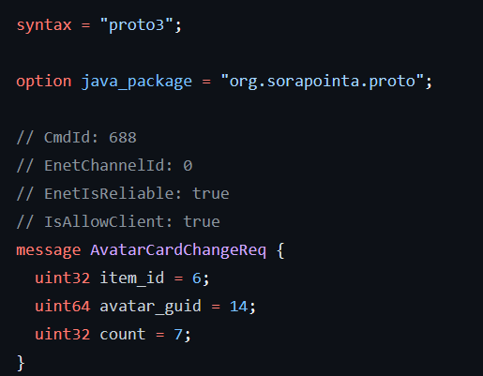**AvatarCardChangeReq.proto v3.2.0** **AvatarCardChangeReq.proto v3.3.0**

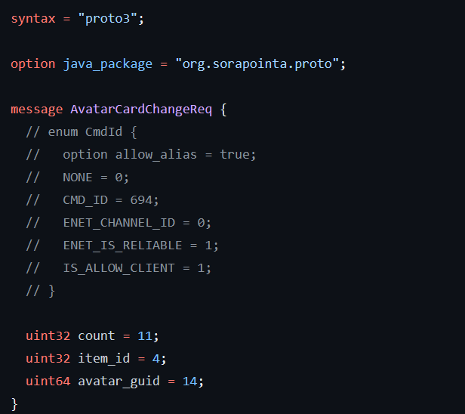

Omg! Proto CmdId different (688 and 694), also field ids different (count, item_id, avatar_guid). That’s why you must use compatible Proto for each version! Otherwise, you game won't load and will stop on a white screen (after opening the gates). Each server bins already compiled with proto (inside).

Because of the different proto ids and fields ids you can’t play game version 3.3 with server bins for 3.2.

# Proto dumping

**Already dumped proto:**

<https://github.com/Sorapointa/Sorapointa-Protos>

<https://gitlab.com/YuukiPS/GC-Proto>

<https://github.com/NickTheHuy/3.3.0_proto.git>

<https://github.com/NickTheHuy/3.4_proto.git>

<https://github.com/NickTheHuy/3.5_protos.git>

<https://git.crepe.moe/crepe-inc/crepe-protos.git>

<https://github.com/CloudyPS/protos.git>

Don't use this proto because proto for some versions not fully restored (cuz it obfuscated)! Dump it by yourself from server bins!

**Protodumpers:**

<https://github.com/marin-m/pbtk> <https://github.com/partypooperarchive/ProtobufDecoder>

<https://github.com/lilmayofuksu/sus-scripts> <https://github.com/partypooperarchive/ObfProtoDecoder>

<https://github.com/nitrog0d/ProtoDumper>

You can use **pbtk** to dump full proto from the server bins all CB and 1.0 up to 3.4 (after 3.2 srv bins proto shuffled by devs cuz leak and 3.3 game server have different proto than 3.3 game release). Just run pbtk gui and select gameserver bins (NOT game, IN server bins. You can dump it from the game BUT I doubt – it is very obfuscated, you can’t restore all fields properly but in servers bins – you can).

KCP/Enet and UDP/TCP

What is the **KCP**? - <https://ims.improbable.io/insights/kcp-a-new-low-latency-secure-network-stack>

Also, you should learn about **TCP/UDP** before!!! Just download books or see youtube guides. Game clients use **KCP** protocol to send protobuf data (see ⁠**proto**). You can use **KCP** Proxy to see Proto data:

<https://github.com/Crepe-Inc/Iridium>

<https://github.com/GrownNed/gidra>

<https://github.com/MoonlightPS/Iridium-gidra>

Some very old game clients use **Enet** instead of **KCP**! Also, you should be able to dump proto (see ⁠**proto dumpers**). And you should be able to restore names/cmdid/fields ids. Also you can play game, record session, decode every proto and see values in proto fields, use brain to figure out how you should do it in your **Private Server,** also you can use **WireShark** to record your game packets to .pcap

Example of the **Iridium** proxy proto visualizer:

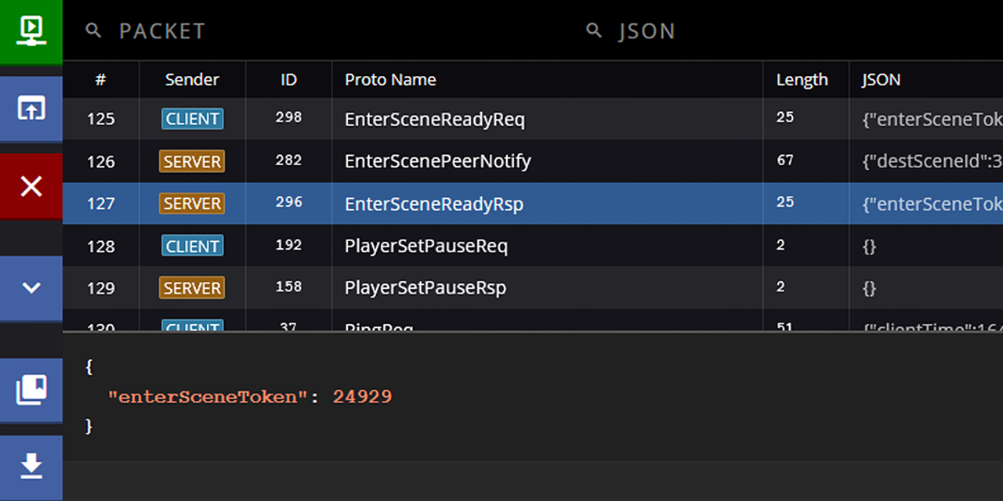

# Proto shifting on the fly using KCP Proxy

As I said before - Because of the different proto ids and fields ids in the different server bins you can’t play game version 3.3 with server bins for 3.2 natively. But we can write a some KCP Proxy to shift all proto ids “on the fly” and convert new Proto ids to old proto ids (or vice versa). This proxy should be in middle between **Game** and **Server** and should decode. Change and encode **protobuf data** via **KCP protocol**. This allows you to play 3.3 game with 3.2 server.

See these repositories of ProtoShifters (choose one):

<https://github.com/YuFanXing/ProtoShift>

<https://github.com/Jx2f/ViaGenshin>

(Or use ViaGenshin from the “**server-requirements.rar**”)

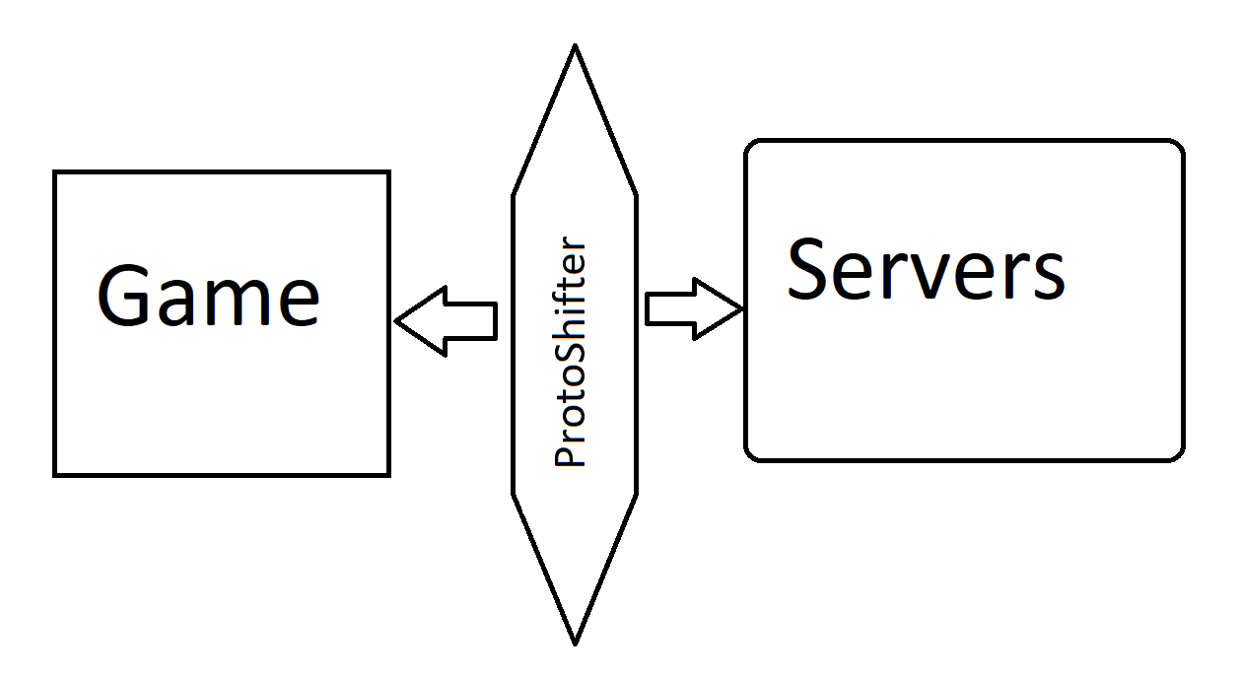

ProtoShifter can change proto ids on the fly in realtime

# Method 2. VM-Installer - run server without Docker in Linux/VMware/Virtualbox/WSL





# Download installer + script

Download "server-3.2-installer.rar" and "server-3.2-installer.sh":

<https://anonfiles.com/Pd59ndo8z9/server_3_2_installer_rar>

<https://anonfiles.com/wc5en6o2z4/server_3_2_installer_sh>

**This installer only for 3.2 version. Server bins for 3.2 and data already in installer archive. Please don’t use this method with installer because the new method with Docker better and support all versions.**

**If links aren’t available – please check new guide in our Discord -** <https://discord.gg/MfxYRNdD9x>

# Prepare your virtual machine

1. Install VMWare / VirtualBox / WSL (one of these of your choice)

For example, links for VMWare PRO:

Download for Win - <https://www.vmware.com/go/getworkstation-win>

Download for Lin - <https://www.vmware.com/go/getworkstation-linux>

**Keys for 17x version:**

MC60H-DWHDS-H80U9-6V85M-8280D

**Keys for 16x version:**

ZF3R0-FHED2-M80TY-8QYGC-NPKYF

YF390-0HF8P-M81RQ-2DXQE-M2UT6

ZF71R-DMX85-08DQY-8YMNC-PPHV8

1. If you using WSL - skip this step. For VBox/VMware create a new VM with 30+ GB of HDD space and 18 Gb or RAM (24 Gb recommended).
2. Install **Ubuntu 20.04 Desktop** or **Server edition** (NOT **Ubuntu 22.04**, it's incompatible). Desktop – with **Graphical User Interface**, server – without it (only black terminal)!

You need ISO of Ubuntu 20.04.5 server OR desktop, which you can get here:

<https://www.releases.ubuntu.com/focal/ubuntu-20.04.5-live-server-amd64.iso>

<https://www.releases.ubuntu.com/focal/>

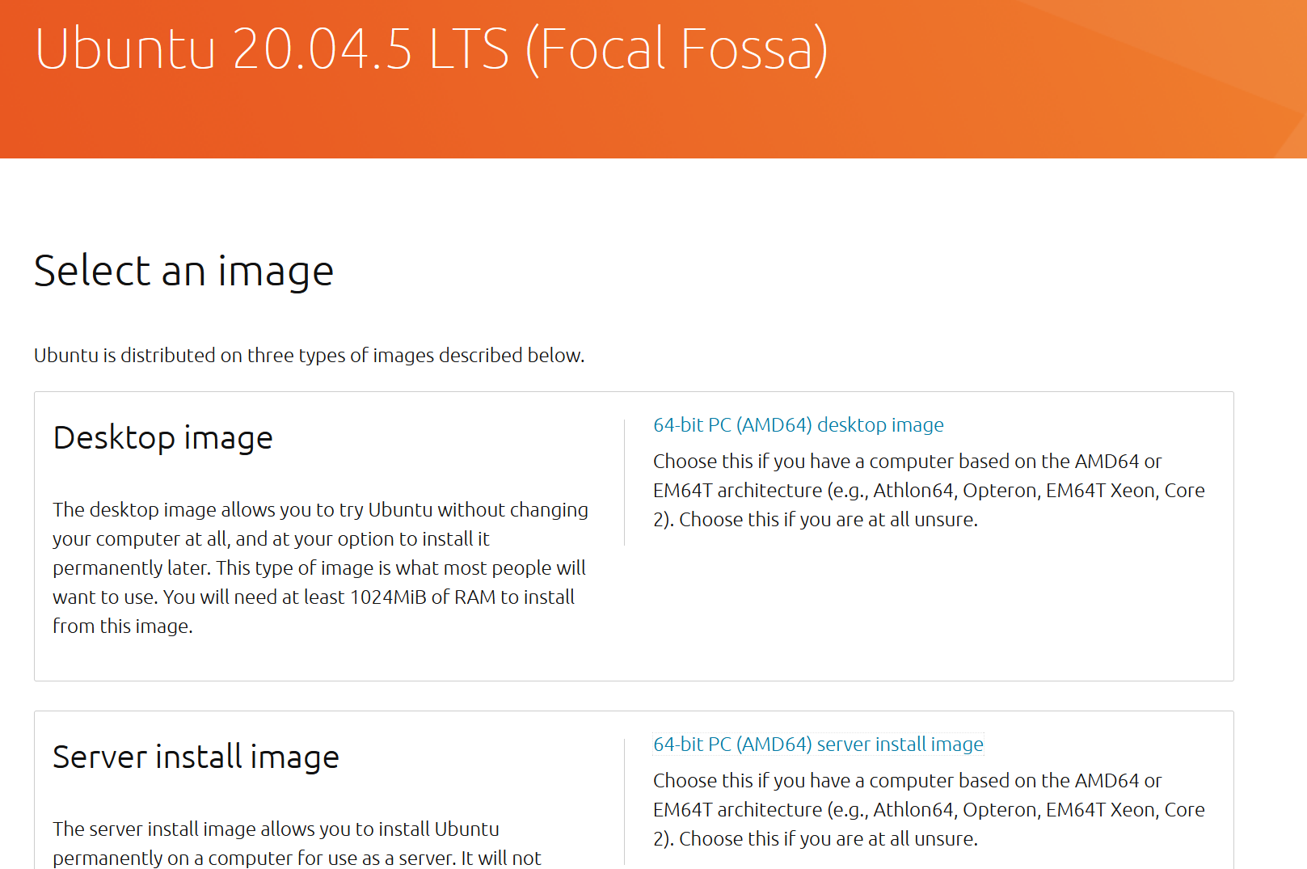

Installation for Desktop is very easy, but if you installing in server mode - very important: when setting up the disk partitioning while installing the ubuntu server, you have to uncheck the "Set up this disk as an LVM group" like on this screenshot:

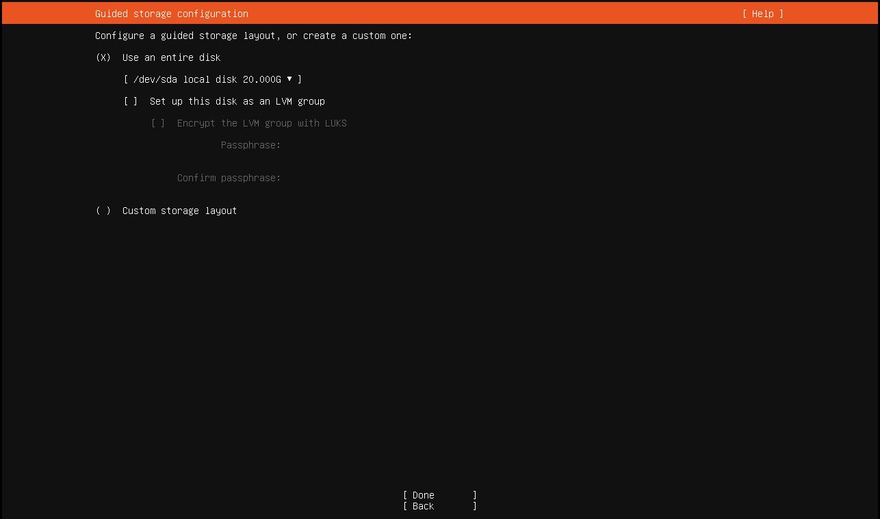

1. If you using **WSL** - skip this step. Open Vmware/VBox networks settings/configuration:

In vmware Edit -> Virtual Network Editor -> (on Bottom clock Change Settings with shield) -> select YES -> click on VMnet with NAT -> in Subnet IP set: 192.168.200.0 and mask 255.255.255.0

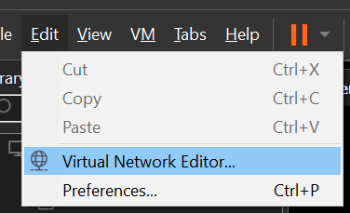

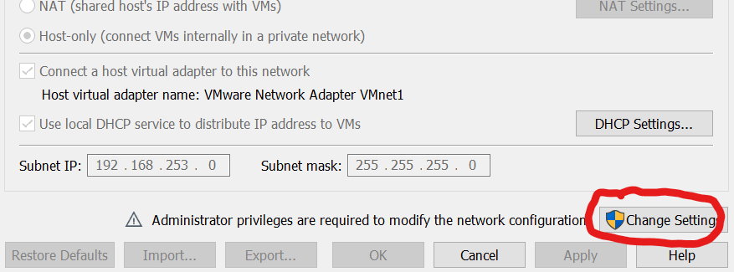

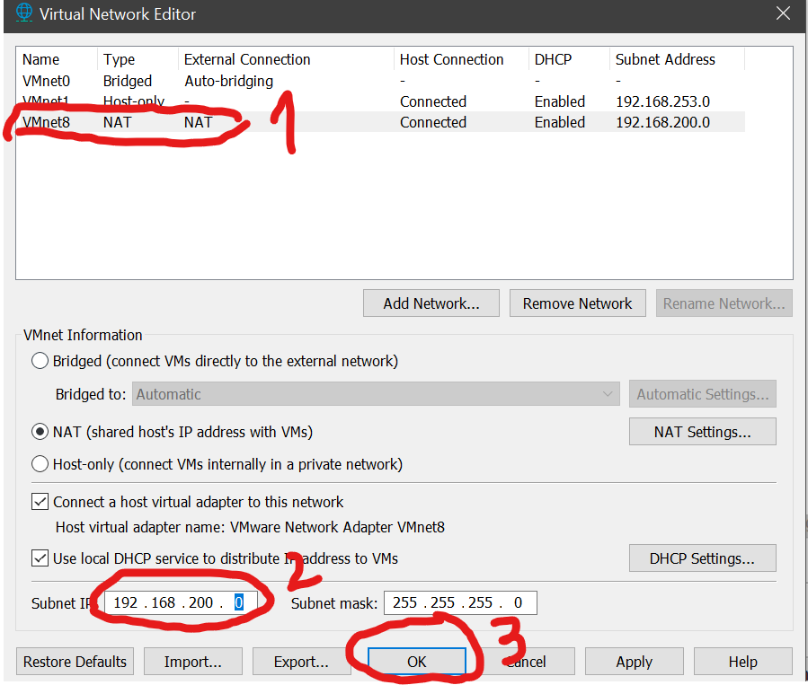

1. If you using WSL - skip this step. If you using Desktop Ubuntu 20.04 - install **VMware/VBox Guest additions** if it not installed yet (search in google how to install it).
2. Set static ip in Ubuntu in VMware/Vbox (I dunno how to do it in WSL).

**For Desktop edition**:

sudo nano /etc/netplan/01-network-manager-all.yaml

**You should do:**

# Let NetworkManager manage all devices on this system

network:

version: 2

renderer: NetworkManager

ethernets:

ens33:

dhcp4: no

addresses: [192.168.200.130/24]

# you can delete this line to disable WAN internet

# instead of using iptables

gateway4: 192.168.200.2

nameservers:

addresses: [1.1.1.1,8.8.8.8]

**For Server edition:**

sudo nano /etc/netplan/00-installer-config.yaml

**You should do:**

# This is the network config written by 'subiquity'

network:

version: 2

ethernets:

ens33:

dhcp4: no

addresses: [192.168.200.130/24]

# you can delete this line to disable WAN internet

# instead of using iptables

gateway4: 192.168.200.2

nameservers:

addresses: [1.1.1.1,8.8.8.8]

1. Apply the IP changes:

sudo netplan --debug apply

1. Enter this command to check your server ip again:

**ip addr**

It should show 192.168.200.130 now. Restart the VM and check IP again.

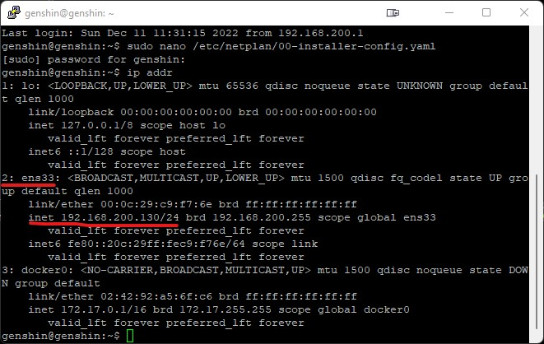

1. Check internet using:

**ping google.com**

**wget google.com**

It should work, you should have internet access (we will disable it later)

1. Go to shared folder:

If you using WSL - you can see all disks using "cd /mnt/ && ls -la". And for example, you can go to "cd /mnt/d/folder1/folder2".

If you using VMware/VBox with installed guest additions - create a shared folder (from VM settings) pointing to the desired location of the server files. Assign this folder to the VM. In vmware you can go to /mnt/hgfs to see mounted folders. In vbox it is a network drive. See below guide for VMware:

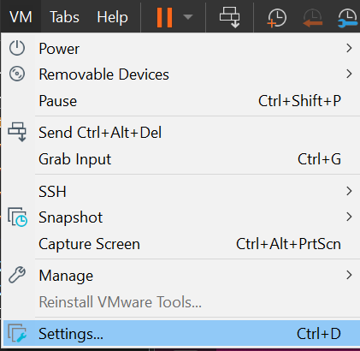

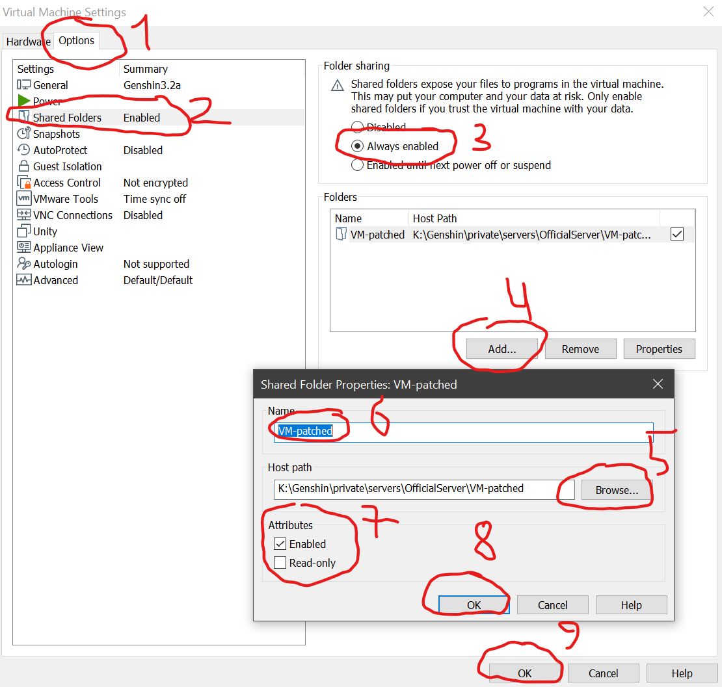

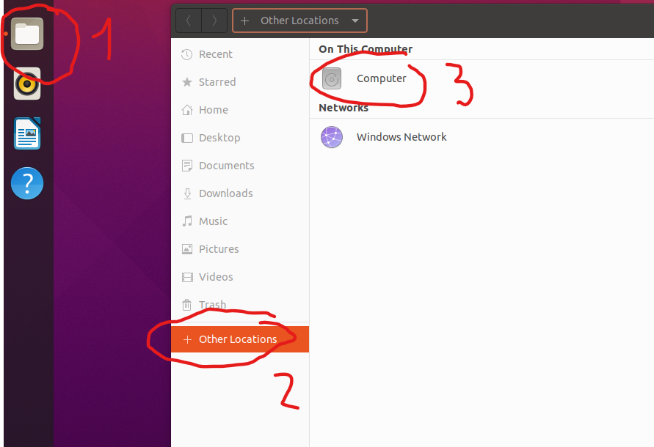

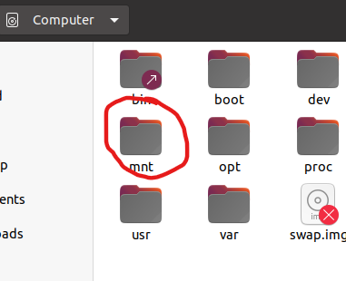

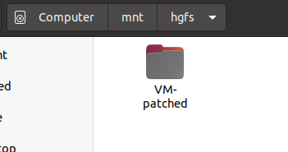

**VM-patched – just my folder name with all installer scripts. You can use another folder name**

1. Allow **HGFS auto mount** on **open-vm-tools** in VMWare

It appears that when you install open-vm-tools on Ubuntu for VMware Workstation the HGFS mount is never created. To get your shared folders to show up we need to perform a few steps.

We need to create the /mnt/hgfs folder.

**sudo mkdir /mnt/hgfs**

To mount your shares temporarily run the following command.

**sudo mount -t fuse.vmhgfs-fuse .host:/ /mnt/hgfs -o allow_other**

To persist the mount you will need to edit the `/etc/fstab` file. Add the following line.

**.host:/ /mnt/hgfs fuse.vmhgfs-fuse allow_other 0 0**

Reboot the host to verify persistence of the mount. If it doesn’t work, try to add another line:

**vmhgfs-fuse /mnt/hgfs fuse defaults,allow_other 0 0**

1. Copy **server-3.2-installer.rar** and **server-3.2-installer.sh** to **/root** or **/home/userName** (don't use it "in place" on your NTFS folder instead of EXT4 Linux - otherwise you will get **VERY** poor performance)
2. Run:

**sudo su**

**cd ~**

**chmod +x server-3.2-installer.sh && ./server-3.2-installer.sh**

Enter access ip: **192.168.200.130**

Enter local ip: **192.168.200.130**

1. If you using VmWare/VBOX - Before start servers you'd better disable WAN access (keep local only) because this servers can leak telemetry to the other real original servers:

For Desktop edition:

**sudo nano /etc/netplan/01-network-manager-all.yaml**

For Server edition:

s**udo nano /etc/netplan/00-installer-config.yaml**

Comment line (add #) with “gateway4: 192.168.200.2”:

**# gateway4: 192.168.200.2**

Save using “ctrl + x” -> “Y” -> Enter

1. Apply the IP changes:

**sudo netplan --debug apply**

1. Try to ping google:

**ping 8.8.8.8**

You shouldn't recieve any bytes!

You should get message like “ping: connect: network unreachable | error | etc”

If you can ping google – network isn’t disabled, try to recheck network settings file…

If you using WSL OR still can ping google - so... In this case - use script from "**requirements/wan disable.sh**"

1. If you need to use internet inside VM again: "requirements/wan enable.sh". ATTENTION! After "wan enable.sh" you should restart all docker containers:

**sudo docker kill $(docker ps -q) && sudo docker start $(docker ps -a -q)**

1. Read how to start from installer when it done

If you wish to start only important servers (set ~16GB RAM, your system should be 20GB+ RAM):

**./cli start**

Following server has been disable in **cli** file:

**# cd ../oaserver**

**# chmod +x oaserver**

**# nohup ./oaserver -i 9001.9.1.1 &**

**# cd ../pathfindingserver**

**# chmod +x pathfindingserver**

**# nohup ./pathfindingserver -i 9001.8.1.1 &**

**# cd ../multiserver**

**# chmod +x multiserver**

**# nohup ./multiserver -i 9001.7.1.1 &**

**# cd ../tothemoonserver**

**# chmod +x tothemoonserver**

**# nohup ./tothemoonserver -i 9001.10.1.1 &**

If you wish to start ALL servers (set ~24GB RAM to VM, your system should be 30GB+ RAM):

**./cli-default start**

And to stop all servers run:

**./cli stop_all**

To show server status run:

**./cli status**

p.s. also you can ./cli stop but it seems stucks, use CTRL + C to terminate and **./cli stop_all**

Also you can run ALL servers (even multiserver for the PVP and tothemoonserver for the Spiral Abyss):

**./cli-default start**

**ATTENTION!**

**./cli** require 16 GB RAM and **./cli-default** requires 23-25 GB RAM

1. Apply Fiddler script from "**requirements/fiddlerScript.txt**"
2. Run Fiddler
3. Run game version 3.2 (NOT 3.3), don't forget to use patched UserAssembly.dll, replace original .dll in game folder in: "GenshinImpact_Data/Native/")
4. Play with full features
5. Read all **GM** commands in previous chapters
6. Also, you can go to the Database admin panel:

Address: **http://192.168.200.130/phpmyadmin**

http! NOT https!

Use login: **root** and pass: **f2c340a9-bf06-4345-9654-00b074b92fe8**

OR login: **work** and pass: **GenshinImpactOffline2022**

If it doesn’t work, then install it inside the VM like this:

**docker run -d --net=host --restart always -e PMA_HOST="127.0.0.1" -e PMA_ARBITRARY="1" --name phpmyadmin phpmyadmin/phpMyAdmin**

# **Method 3. Run already prepared server VM image using VMWare only**



-) Install VmWare PRO

Download for Win - <https://www.vmware.com/go/getworkstation-win>

Download for Lin - <https://www.vmware.com/go/getworkstation-linux>

-) Keys for 17x version:

MC60H-DWHDS-H80U9-6V85M-8280D

Keys for 16x version:

ZF3R0-FHED2-M80TY-8QYGC-NPKYF

YF390-0HF8P-M81RQ-2DXQE-M2UT6

ZF71R-DMX85-08DQY-8YMNC-PPHV8

-) Configure Internet

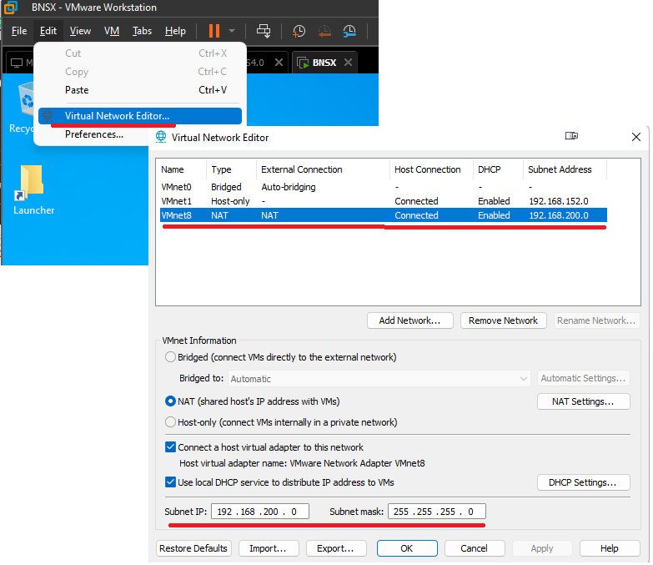

-) Download and unpack **UbuntuServer-20.04-Genshin-3.2-x64.7z** (7 GB total)**:**

<https://anonfiles.com/224fEcofz1/UbuntuServer_20_04_Genshin_3_2_x64_7z>

OR **UbuntuDesktop-20.04-Genshin-3.2-x64.7z** (10 GB total)**:**

<https://anonfiles.com/m7k6Cfo3zb/UbuntuDesktop_20_04_Genshin_3_2_x64_7>z

**Also, you can try to search in I2P or TOR links if the links above unavailable:**

I2P Site URL (recommended, stable connection): <http://ufqsp7hhjc6hvbcqpiumocavnqu7ufpuvcfuynwew63dvoujqa3a.b32.i2p/>

TOR ONION Site URL (NOT recommended, unstable connection): <http://b4ssb6i52vqyybsttuhax2wsp22td4rei6kmk2vt3nzj2hj5v54y5nyd.onion/>

-) Open file Genshin3.2.vmx, virtual machine should appear in your VMWare dashboard

-) Configure VM using settings:

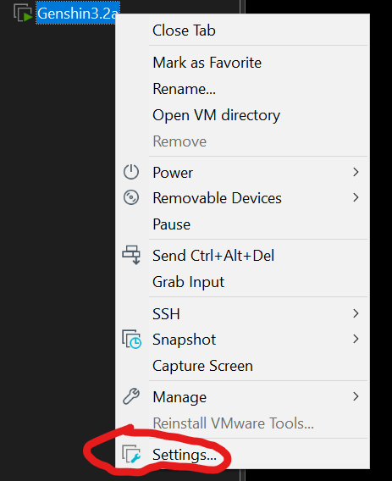

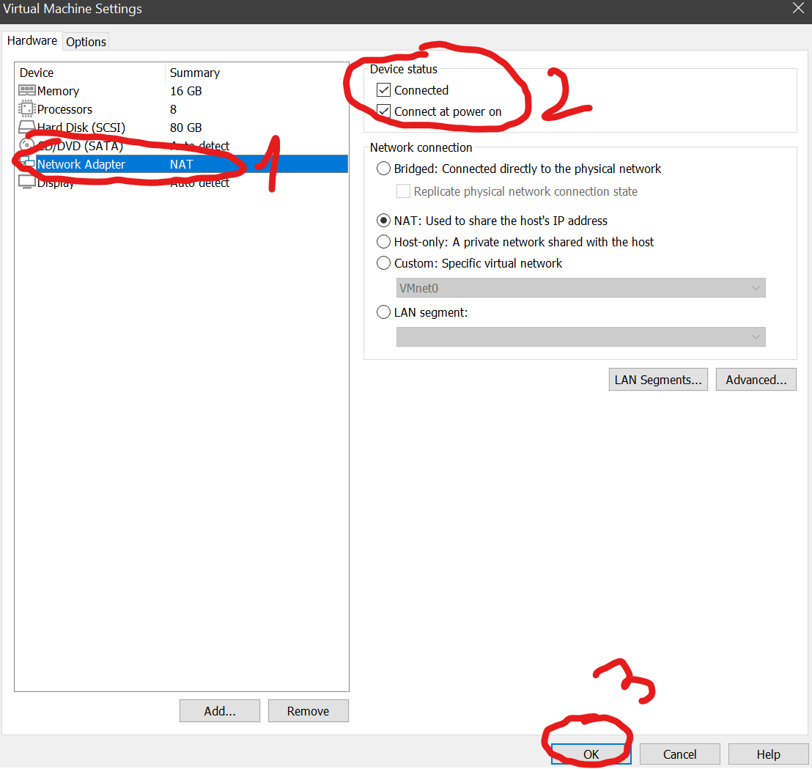

-) Start VM and login using login and password:

Login: genshin

Password: Genshin2023@@

-) You can connect to VM using: WSL:

**ssh** [**genshin@192.168.200.130**](mailto:genshin@192.168.200.130)

and write password OR using GUI Putty

-) Also, you can setup Desktop GUI in **Server edition** (if you using Desktop edition – just **SKIP** this steps):

**sudo su**

**apt update && apt upgrade -y**

**apt install -y slim wget net-tools ubuntu-desktop**

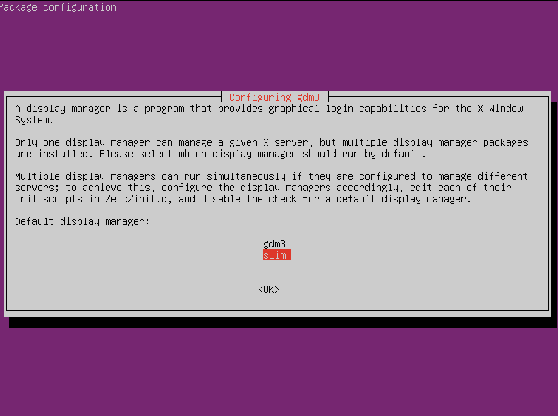

You can choose gdm3 OR slim.

Slim:



Gdm3:

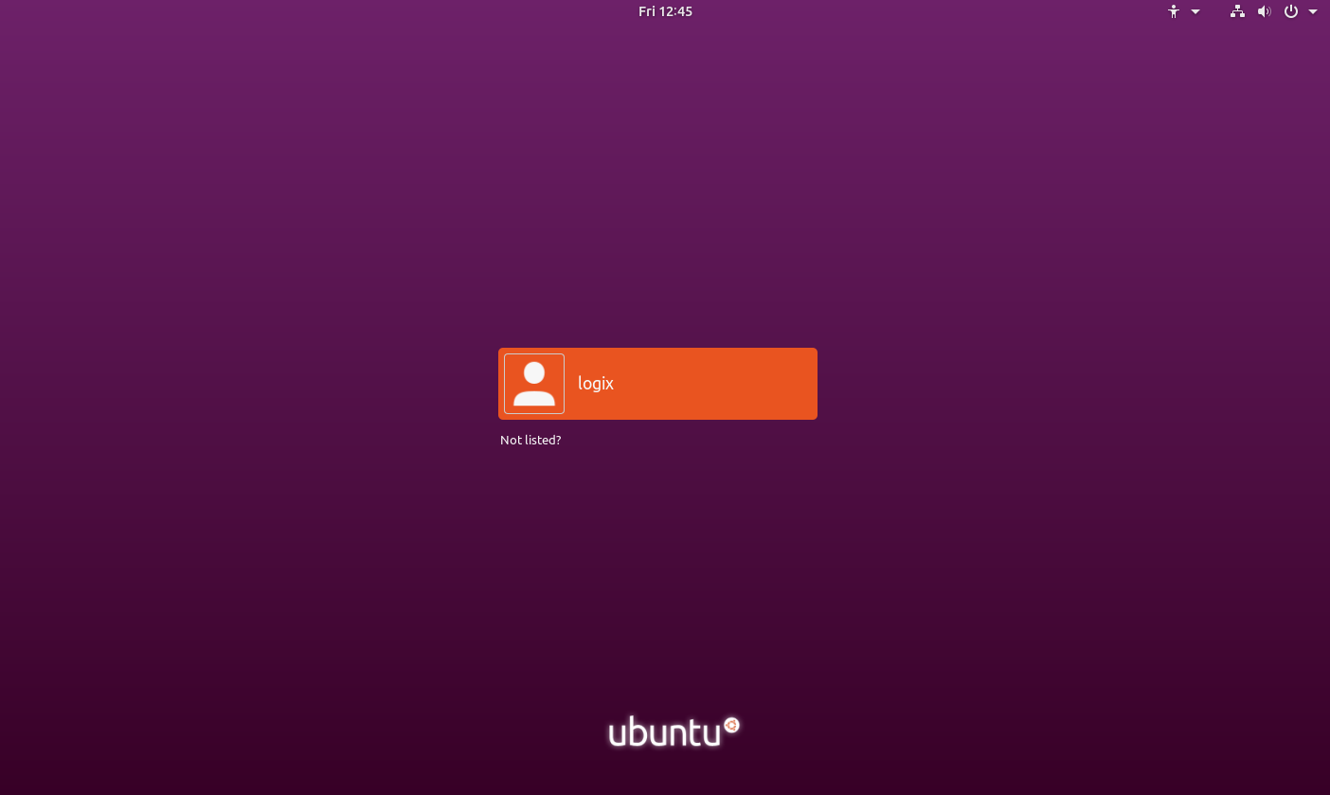

After GUI installation do:

**reboot**

Graphical interface:



Next -> Next -> Done

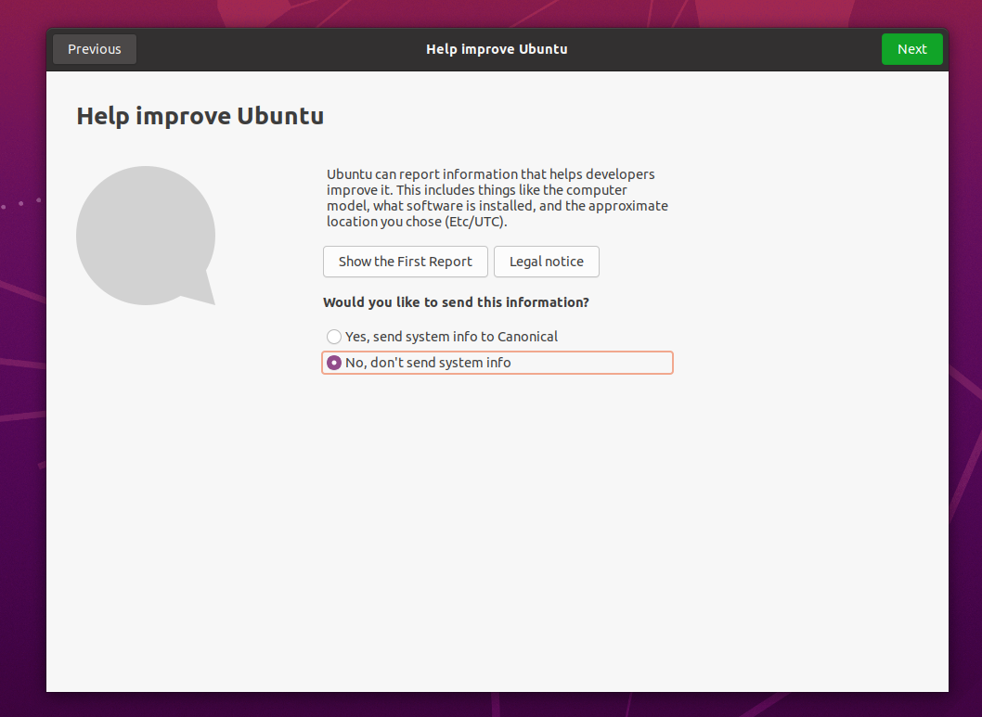

**Don’t upgrade to 22.04. DON’T.**

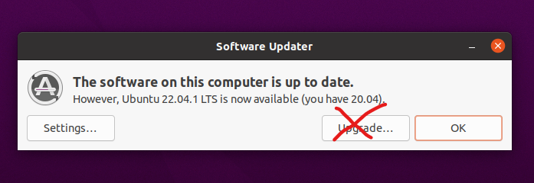

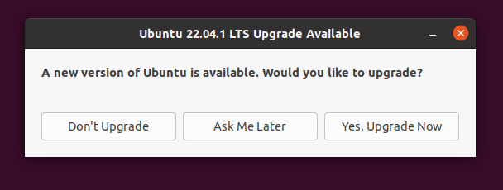

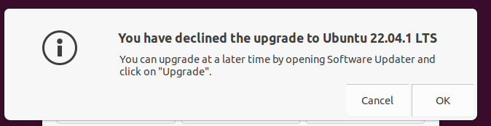

-) Start game server for 3.2 version:

**sudo su**

**cd /root/genshin/srv**

**chmod +x ./cli**

**chmod +x ./cli-default**

-) Disable VM internet (keep local only):

For Desktop edition:

**sudo nano /etc/netplan/01-network-manager-all.yaml**

For Server edition:

**sudo nano /etc/netplan/00-installer-config.yaml**

Comment line (add #) with “gateway4: 192.168.200.2”:

**# gateway4: 192.168.200.2**

Save using “ctrl + x” -> “Y” -> Enter

-) Apply the IP changes:

**sudo netplan --debug apply**

-) Try to ping google:

**ping 8.8.8.8**

You shouldn't receive any bytes!

You should get message like “ping: connect: network unreachable | error | etc”

If you can ping google – network isn’t disabled, try to recheck network settings file…

-) If you wish to start only important servers (set ~16GB RAM, your system should be 20GB+ RAM):

**sudo ./cli start**

Following server has been disable in cli file:

**# cd ../oaserver**

**# chmod +x oaserver**

**# nohup ./oaserver -i 9001.9.1.1 &**

**# cd ../pathfindingserver**

**# chmod +x pathfindingserver**

**# nohup ./pathfindingserver -i 9001.8.1.1 &**

**# cd ../multiserver**

**# chmod +x multiserver**

**# nohup ./multiserver -i 9001.7.1.1 &**

**# cd ../tothemoonserver**

**# chmod +x tothemoonserver**

**# nohup ./tothemoonserver -i 9001.10.1.1 &**

-) If you wish to start ALL servers (set ~24GB RAM to VM, your system should be 30GB+ RAM):

**./cli-default start**

You will see (**ERRORs in DataLoader and Crypto** is normal, it’s OK, just dirty trick with Grasscutter SDKserver):

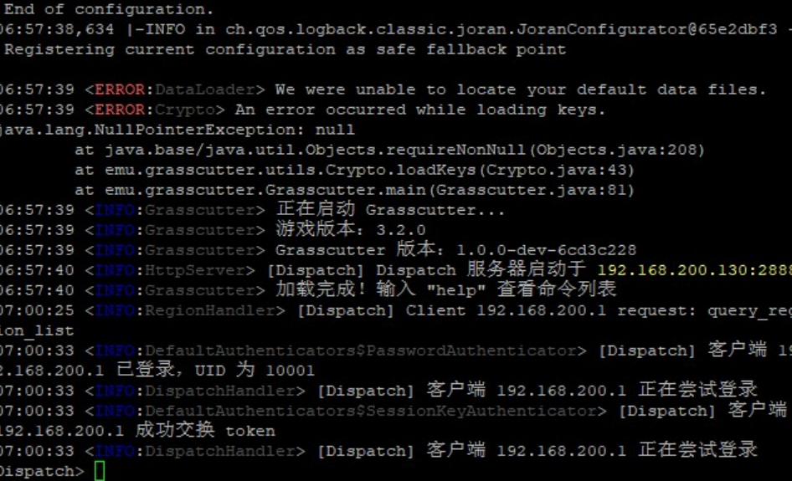

-) In your GAME Replace the UserAssembly.dll in Genshin\GenshinImpact_Data\Native game folder with the one from “requirements.rar”.

-) Choose: Fiddler or Cultivation. I prefer Fiddler.

-) For Fiddler use script “fiddlerScript.txt” from “requirenents.rar” – start Fiddler app, go to FIddlerScript (inside app), replace all script to text from “fiddlerScript.txt” and save, done

-) For Cultivation - https://github.com/Grasscutters/Cultivation/releases/

https://github.com/Grasscutters/Cultivation/releases/download/v1.0.10-alpha/Cultivation_1.0.10_x64_en-US.msi

Launch Cultivation, go to Options.

Set Game Install Path to your Genshin Game folder

Uncheck Automatically Path Metadata

Check Use Internal Proxy

Check Connect via Grasscutter

IP: 192.168.200.130

Port: 2888

Uncheck Use HTTPS

Click Launch to play.

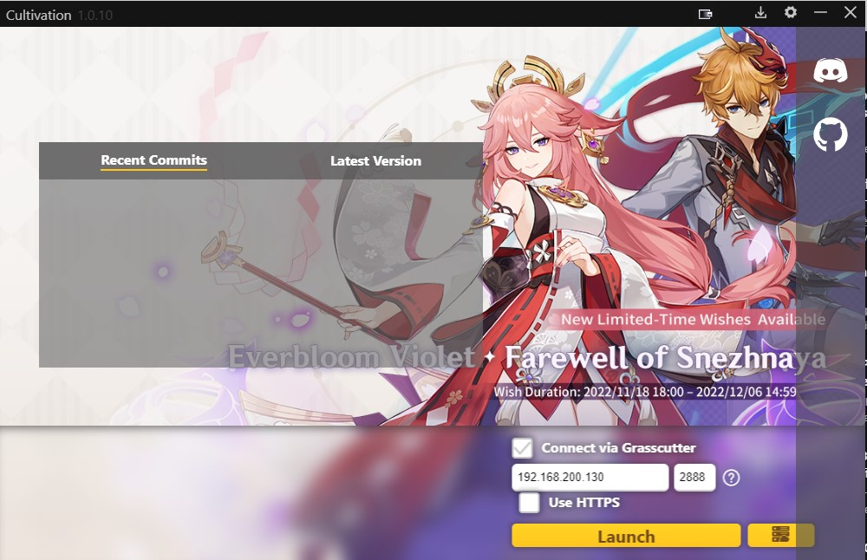

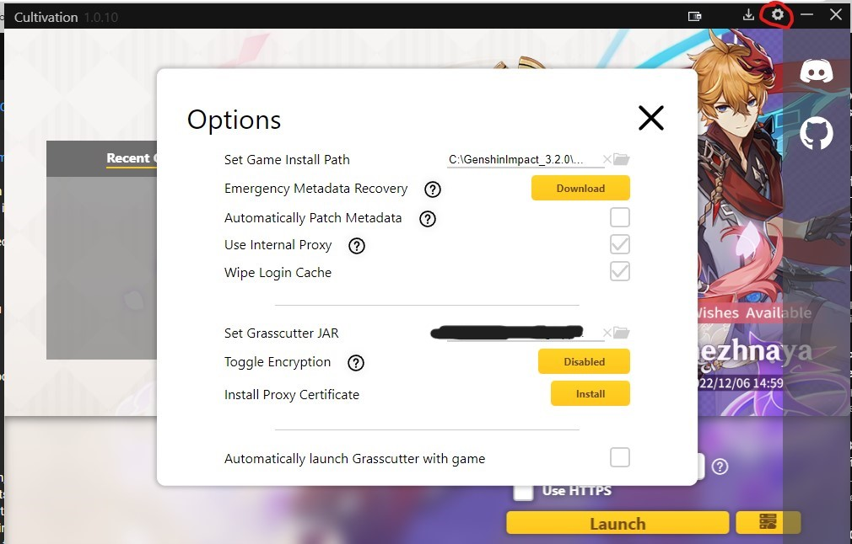

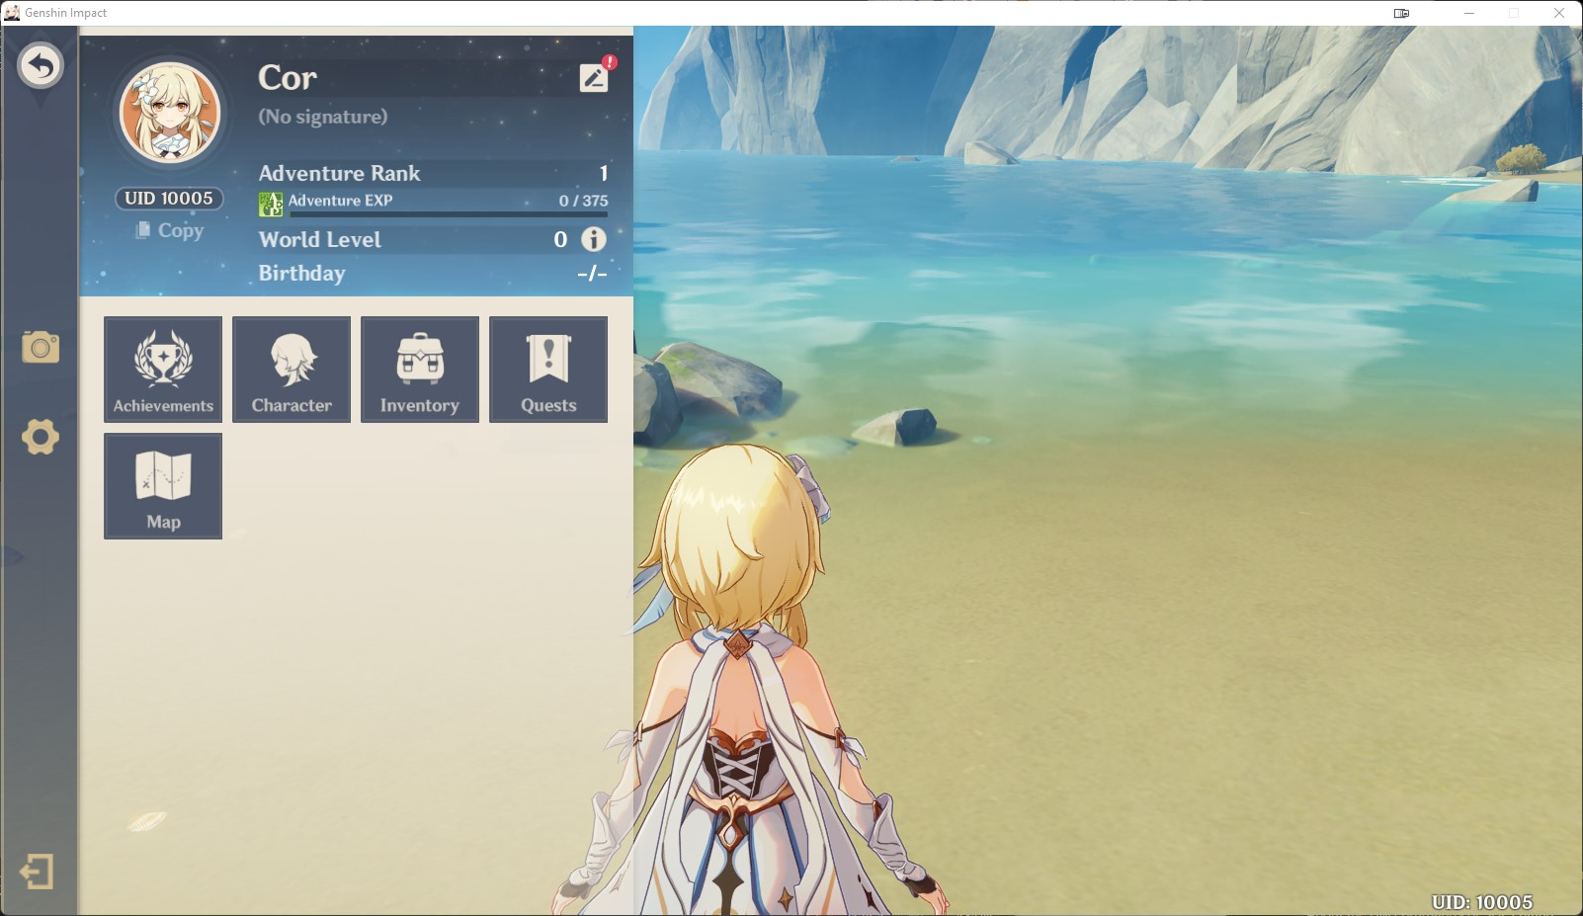

**PLEASE USE FIDDLER IF YOU CAN’T CONNECT USING CULTIVATION**

-) You can write ANY login (just remember), server will create new if doesn’t exist. OR you can use existing (not recommended):

username: Test

Password: 123456

-) Probably, you already have phpMyAdmin, go to

<http://192.168.200.130> and check it. http! NOT https!

If it doesn’t work, then install it inside the VM like this:

**docker run -d --net=host --restart always -e PMA_HOST="127.0.0.1" -e PMA_ARBITRARY="1" --name phpmyadmin phpmyadmin/phpmyadmin**

Use login: root and pass: f2c340a9-bf06-4345-9654-00b074b92fe8

OR login: work and pass: GenshinImpactOffline2022

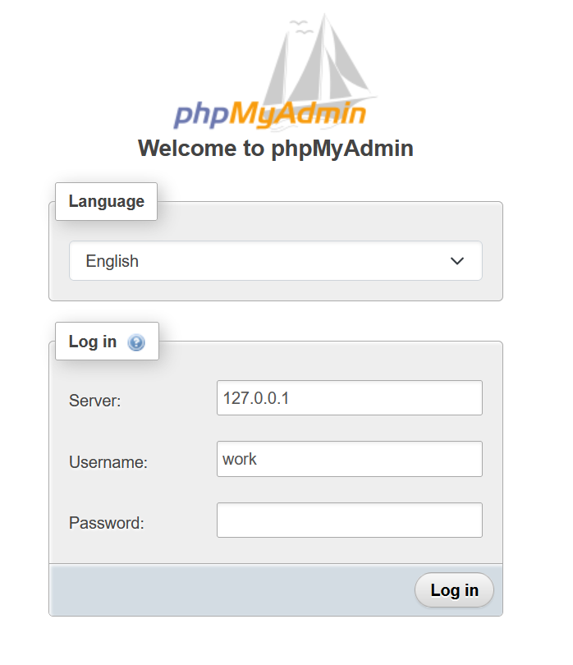

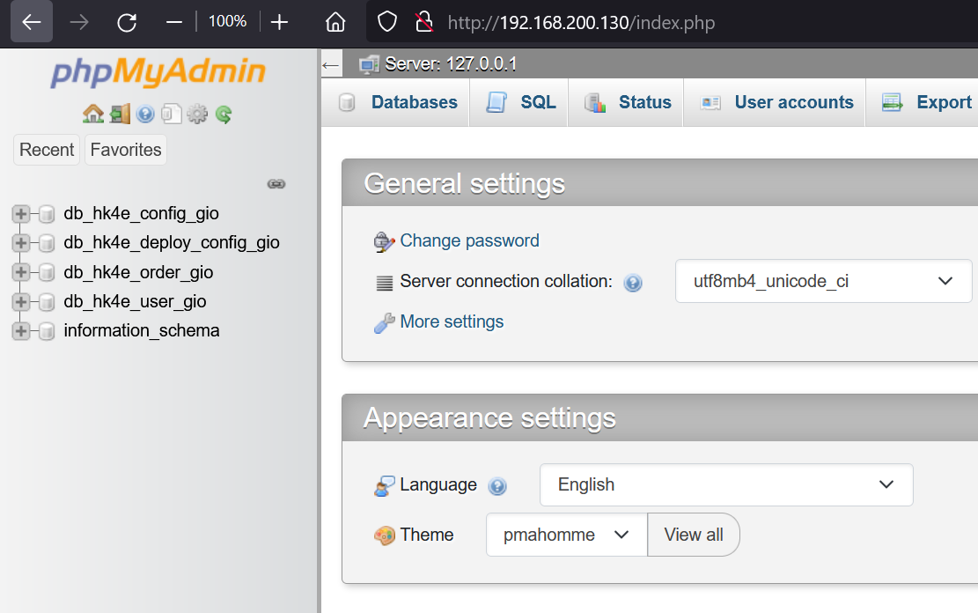

# Method 1. Run server in Linux native/WSL without Docker/Vmware/Virtualbox



-) Download non-configured server bins and data "as is" (I guess you already downloaded it from the **“Method 5. GIO Dockers”**

Notice: we'll be using a bundled dispatch server, but it can only serve HTTP. You will need to wrap HTTPS traffic from the client by using e.g. mitmproxy OR Fiddler (recommended).

-) Install VMWare / VirtualBox / WSL

-) Install Ubuntu 20.04 Desktop or Server edition (NOT Ubuntu 22.04, it's incompatible)

-) If you using WSL - skip this step. Open Vmware/VBox networks settings/configuration:

in vmware Edit -> Virtual Network Editor -> (on Bottom clock Change Settings with shield) ->

select YES -> click on VMnet with NAT -> in Subnet IP set: 192.168.200.0 and mask 255.255.255.0

-) If you using WSL - skip this step. For VBox/VMware create a new VM with 20 Gb of HDD space and 10 Gb or RAM (16 Gb recommended).

-) If you using WSL - skip this step. If you using Desktop Ubuntu 20.04 - install VMware/VBox Guest additions if it not installed yet (search in google how to install it).

-) Set static ip ONLY in VMware/Vbox (I dunno how to do it in WSL, you should find solution itself):

For Desktop edition:

sudo nano /etc/netplan/01-network-manager-all.yaml

# Let NetworkManager manage all devices on this system

network:

version: 2

renderer: NetworkManager

ethernets:

ens33:

dhcp4: no

addresses: [192.168.200.130/24]

# you can delete this line to disable WAN internet

# instead of using iptables

gateway4: 192.168.200.2

nameservers:

addresses: [1.1.1.1,8.8.8.8]

For Server edition:

sudo nano /etc/netplan/00-installer-config.yaml

# This is the network config written by 'subiquity'

network:

version: 2

ethernets:

ens33:

dhcp4: no

addresses: [192.168.200.130/24]

# you can delete this line to disable WAN internet

# instead of using iptables

gateway4: 192.168.200.2

nameservers:

addresses: [1.1.1.1,8.8.8.8]

-) Apply the IP changes:

sudo netplan --debug apply

-) Enter this command to check your server ip again:

ip addr

It should show 192.168.200.130 now, and restart the VM. Check ip again. Check internet

using:

ping google.com

wget google.com

It should work, you should have internet access (we will disable it later)

-) Go to shared folder:

If you using WSL - you can see all disks using "cd /mnt/ && ls -la". And for example you can go to "cd /mnt/d/folder1/folder2".

If you using VMware/VBox with installed guest additions - create a shared folder (from VM settings) pointing to the desired location of the server files. Assign this folder to the VM. In vmware you can go to /mnt/hgfs to see mounted folders. In vbox it is a network drive

-) Copy original server bins (for example: server-3.2-3.4-original-bins.rar) to /root or /home/userName (don't use it "in place" on your NTFS folder instead of EXT4 Linux - otherwise you will get VERY poor performance)

-) use command "unrar" or "unzip" to extract original bins, for example:

sudo apt install unrar unzip

unrar server-3.2-bins.rar

-) Create "server" directory, create "tools/op_tools" subdirectories in "server"

-) Move all file and folders from "3.2-sql" (from **server-1.0-3.2-configs.rar** archive) into "server/tools/op_tools" subdirectory.

-) Move all files and folders from "welink_3.2_qa.7z" (from **server-1.0-4.0-data.rar**) into "server/data/" subdirectory.

-) Create a new empty "server/res/" directory at the root "server" folder (nearby server/data/, NOT inside server/data/ !!!). If no "res/" folder - Gameserver will fail

-) Copy provided version.txt (from "**server-requirements.rar**") file into the "server/data/" subdirectory too.

-) Create "conf/dev" in server/tools/ and put "dev_gio.yaml" (from "**server-requirements.rar**") into the directory "server/tools/op_tools/conf/dev".

-) Register this config in "server/tools/op_tools/conf/global.xml" by adding a line <Region name="dev_gio" conf_file="dev/dev_gio.yaml" region_id="9001"/>

-) Change line #418 in "tools/op_tools/bin/build_conf.py" from env="test" to env="dev". Comment by adding "#" before line or remove lines 162 and 196.

-) Change line #108 in "tools/op_tools/bin/server_parse.py" from env="test" to env="dev"

-) update_sql.py - in line 51 replace "sh sql_info_merge.sh " to "bash sql_info_merge.sh "

-) Comment line #173 with "dump_yaml(suffix_name, host, port_begin)" in ready_deploy_dev.py. Add new line #150 with an argument auth_plugin='mysql_native_password'

Must be like that:

mydb = mysql.connector.connect(

host=mysqlInfo[0]['host'],

user=mysqlInfo[0]['user'],

passwd=mysqlInfo[0]['pwd'],

auth_plugin='mysql_native_password'

)

-) Add new line #154 with text:

mycursor.execute("CREATE DATABASE IF NOT EXISTS db_hk4e_deploy_config_{0}".format(suffix_name))

Next steps are preformed inside the VM

-) Set timezone to UTC using:

sudo dpkg-reconfigure tzdata - select "None of this" -> "UTC" -> OK

-) Run:

echo "$SHELL"

You will see /bin/bash if not - set bash as a default system-wide shell by running "dpkg-reconfigure dash"

-) Install **openssh-server** and configure it for passwordless login of your user (with a key file).

**apt install ssh**

You can also just type the password everytime scripts require it, but that's a ton of typing...

-) Install git

**sudo apt install git**

-) Install golang:

**sudo apt install golang-go golang**

If you fail with go --classic install, use another comand:

**sudo snap install go --classic**

-) Install mysql-server, libmysqlclient-dev, redis and gawk:

**sudo apt install mysql-server libmysqlclient-dev redis gawk**

-) Stop service

**sudo service mysql stop**

-) Remove default stored database (DON'T DO THAT IF YOU ALREADY HAVE IMPORTANT MYSQL DATA)

**sudo rm -rf /var/lib/mysql**

-) Create a new dir

**sudo mkdir /var/lib/mysql**

-) Change owner to mysql (user and group)

**sudo chown -R mysql:mysql /var/lib/mysql**

**sudo chmod -R 750 /var/lib/mysql**

-) Create MySQL initial data WITHOUT root password (we will set it later)

**sudo mysqld --initialize-insecure**

-) Start mysql servise:

**sudo service mysql start**

- Check mysql service:

**sudo service mysql status**

- Connect to DB:

**mysql -u root**

- You can set password for the root:

**ALTER USER 'root'@'localhost' IDENTIFIED WITH mysql_native_password BY 'YOUR_PASSWORD_HERE';**

- Create user "work":

**create user 'work'@'localhost' identified by 'GenshinImpactOffline2022';**

- Set password "GenshinImpactOffline2022" and auth method "mysql_native_password":

**ALTER USER 'work'@'localhost' IDENTIFIED WITH mysql_native_password BY 'GenshinImpactOffline2022';**

- Grant all priveleges to this user:

**GRANT ALL PRIVILEGES ON *.* TO 'work'@'localhost' WITH GRANT OPTION;**

-Flush:

**FLUSH PRIVILEGES;**

- Type:

**Exit;**

-) ONLY IF YOU HAVE TROUBLES:

**sudo service mysql restart**

-) Setup Redis: default password "GenshinImpactOffline2022". Increase databases number to 20.

**sudo nano /etc/redis/redis.conf**

We change in the file, looking for a column:

####### SECURITY ######

Use CTRL + W to open search, insert "# requirepass foobared" (ctrl + v or right click)

after it insert "requirepass GenshinImpactOffline2022" without "#"

Like this:

# requirepass foobared

requirepass GenshinImpactOffline2022

Search and replace:

databases 16 -> databases 20

Press CTRL + X, Press (Y) and Enter to save file

-) Restart Redis "/etc/init.d/redis-server restart"

-) Install python2.7 and python2.7-dev

**sudo apt install -y python2-minimal python2.7-dev**

ONLY if you can't call python2 via terminal - make a symbolic link /usr/bin/python2

and try again

-) Install python-pip and using pip2 install requests, Jinja2, enum and pyyaml packages.

Run only for Ubuntu 20.04:

**cd ~ && wget https://bootstrap.pypa.io/pip/2.7/get-pip.py**

**python2 get-pip.py**

(if you can’t wget **get-pip.py –** try to use **get-pip.py** from the"**server-requirements.rar**")

Run only for Ubuntu 22.04:

**sudo apt install python-pip**

Run for both Ubuntu20.04/22.04:

**pip2 install requests Jinja2 enum pyyaml**

-) Download and unpack a very old version of **mysql-connector-python** package:

**wget https://downloads.mysql.com/archives/get/p/29/file/mysql-connector-python-2.0.5.tar.gz**

**tar -xf mysql-connector-python-2.0.5.tar.gz**

**rm mysql-connector-python-2.0.5.tar.gz**

OR if this file deleted use "**mysql-connector-python-2.0.5**" from the "**server-requirements.rar**"

-) Install this package:

**cd mysql-connector-python-2.0.5**

**sudo python2 setup.py install**

-) Clone "schemalex" into "tools/" directory. (After cloning you will get: tools/schemalex):

**cd tools**

**git clone https://github.com/schemalex/schemalex**

OR if this rep deleted use folder "**schemalex**" from the "**server-requirements.rar**"

-) Rename it to "tools/schemalex_tool" (because multiple server sources uses "./../../schemalex_tool/bin/schemalex")

**mv schemalex/ schemalex_tool/**

-) Go to:

**cd schemalex_tool/**

-) Install make:

**sudo apt install make**

-) Build it:

**make build**

-) Go to:

**cd /artifacts/v0.1.1/schemalex_linux_amd64**

-) Show by:

**ls**

You will see 3 bins: schemadiff, schemalex, schemalint

-) Move this 3 compiled binaries into "schemalex/bin" subfolder, create if necessary.

**mkdir -p ../../../bin**

**mv schemadiff ../../../bin/**

**mv schemalex ../../../bin/**

**mv schemalint ../../../bin/**

-) Start all services:

**sudo service mysql start**

**sudo service redis-server start**

**sudo service apache2 start**

(if you using WSL you need to start it every time manually!)

-) Install phpmyadmin:

**sudo apt install phpmyadmin**

(Mark using space button "configure apache2" and press tab to move to "OK" and enter)

You may see error, but its ok:

* Starting Apache httpd web server apache2 [Fri Dec 23 03:39:41.181001 2022] [core:warn] [pid 23148] (92)Protocol not available: AH00076: Failed to enable APR_TCP_DEFER_ACCEPT

-) Go to the DataBase admin panel:

<http://192.168.200.15/phpmyadmin>

Where 192.168.200.15 is YOUR_VM_IP (use "**ip addr**" OR "**sudo apt install -y net-tools && ifconfig**" to check IP)

-) In phpmyadmin select Import and select "db_hk4e_all.sql" from "requirements.rar/" and GO/OK/Import. After that you should see 4 new databases (on the left side, hk4e). Check it!

ONLY if you can't do it using phpmyadmin - do it via terminal:

**sudo mysql -u work -p < db_hk4e_all.sql**

Enter password: GenshinImpactOffline2022

PLEASE don't do that if you already did it using phpmyadmin

-) SKIP THIS STEP. SKIP. It's not a step, just info. How we got "db_hk4e_all.sql"? Do:

**python2 ready_deploy_dev.py dev_gio**

**python2 update_sql.py dev_gio**

**sudo mysql db_hk4e_deploy_config_gio < tools/op_tools/sql_temp/0.1/hk4e_db_deploy_config.sql**

Insert custom prepared data to:

db_hk4e_deploy_config_gio.t_area_config

db_hk4e_deploy_config_gio.t_bind_config

db_hk4e_deploy_config_gio.t_channel_id_config

db_hk4e_deploy_config_gio.t_client_channel_id_config

db_hk4e_deploy_config_gio.t_client_config

db_hk4e_deploy_config_gio.t_client_region_config

db_hk4e_deploy_config_gio.t_rsakey_config

db_hk4e_deploy_config_gio.t_sdk_config

db_hk4e_user_gio.t_player_uid

t_region_config

And modify client version, UID, RSA keys and all URLs.

DON'T DO THIS STEP. It's just info how "**db_hk4e_all.sql**" generated, you already HAVE it in "**server-requirements.rar**"

-) change in op_tools/conf/dev/dev_gio.yaml:

in "server_list" change: "host" and "inner_ip" and "outer_ip" to YOUR_VM_IP (use "ifconfig" to show networks)

-) Cd to:

**cd ../../../../op_tools/bin/**

-) Run:

**bash deploy_dev dev_gio config**

You will see a lot of "skip" if you are using WSL/Native linux or ssh if you are running it under remote machine

-) Run:

**bash deploy_dev dev_gio reload**

You will see:

[172.21.88.25] kill -s SIG........

Now you should have configs and data ready.

-) Now you have a server structure and database structure with all the reqiured tables + data.

-) Copy all folders from "srv-bins/3.2_beta/hk4e_output/" to the "server/" directory.(nearby tools and data folders, a lot of folders already exists in "server/" but its ok to override them).

-) If you are using WSL - skip this step. Only for Ubuntu20.04 Native or VMware or VBox do:

**cd server/lib/ && echo $(pwd) > /etc/ld.so.conf.d/genshin.conf && ldconfig**

To register .so libs in the system (.so - like .dll for Linux)

-) install screen:

**sudo apt install screen**

-) If you using VMWare/VBOX - Before start you can disable WAN access (because this servers leak telemetry to the other real original servers) by removing

this line: "gateway4: 192.168.200.2" from your network settings

(see above) and restart network:

sudo netplan --debug apply

Try:

**ping google.com**

You shouldn't recieve any bytes!

If you using WSL OR still can ping google in VMWare/VBox - so... In this case - use script from "requirements/wan disable.sh"

If you need to use internet inside VM again: "requirements/wan enable.sh".

-) Run all screens:

**sudo screen -dmS gateserver && sleep 1 && sudo screen -r gateserver -X stuff 'cd gateserver && ./gateserver -i 9001.1.1.1\n'**

**sudo screen -dmS gameserver && sleep 1 && sudo screen -r gameserver -X stuff 'cd gameserver && ./gameserver -i 9001.2.1.1\n'**

**sudo screen -dmS nodeserver && sleep 1 && sudo screen -r nodeserver -X stuff 'cd nodeserver && ./nodeserver -i 9001.3.1.1\n'**

**sudo screen -dmS dbgate && sleep 1 && sudo screen -r dbgate -X stuff 'cd dbgate && ./dbgate -i 9001.4.1.1\n'**

**sudo screen -dmS dispatch && sleep 1 && sudo screen -r dispatch -X stuff 'cd dispatch && ./dispatch -i 9001.5.1.1\n'**

You may see: ==1055==WARNING: ASan doesn't fully support makecontext/swapcontext functions and may produce false positives in some cases!

It's OK

p.s. Also you can use "killall screen" to kill all screens and stop all servers if you want to stop

-) Show all screens (check all!):

**sudo screen -list**

-) [skip this step] Also you can attach to screen and see logs:

screen -r [name], for example: screen -r gateserver

To detach screen and keep running in background: Ctrl + A, Ctrl + D (press sequentially)

-) Wait for the server start and ready until 10-15 minutes if you are using HDD (it's not a joke).

You can open Task manager and look for nodeserver, gateserver, dbgate, dispatch, gameserver RAM and dick usage.

Also, you can install htop (task manager):

sudo apt install -y htop

And go to htop:

**htop**

Press F10 to exit

-) Go to SDK server emulator from "server-requirements.rar/SDK Servers/sdkserver.rar" and change in config.json 172.21.88.206 to YOUR VM IP (use "ifconfig" to show networks) and save:

"dispatch": {

"regions": [

{

"Name": "os_usa",

"Title": "Grasscutter",

"type": "DEV_PUBLIC",

"DispatchUrl": "http://172.21.88.206:20001/query_cur_region"

}

],

-) Start SDKServer using "start sdkserver.bat"

-) Install FiddLer, open Fiddler, go to FiddlerScript and put data from "fiddlerScript.txt" (in "server-requirements.rar/Fiddler scripts") and save script, don’t close Fiddler

-) Start game 3.2 (NOT 3.3), now you should be able to connect & play. Enjoy!

-) If you want to see open ports:

**sudo lsof -i -P -n | grep LISTEN**

-) If your vm ip changed, do again:

1. Change manually in op_tools/conf/dev/dev_gio.yaml:

in "server_list": "host" and "inner_ip" and "outer_ip" to YOUR_VM_IP (use "ifconfig" to show networks)

2. Rerun config:

**cd ../../../../op_tools/bin/**

**bash deploy_dev dev_gio config**

**bash deploy_dev dev_gio reload**

3. Run services:

**sudo service mysql start**

**sudo service redis-server start**

**sudo service apache2 start**

4. Rerun screens:

**killall screen**

**sudo screen -dmS gateserver && sleep 1 && sudo screen -r gateserver -X stuff 'cd gateserver && ./gateserver -i 9001.1.1.1\n'**

**sudo screen -dmS gameserver && sleep 1 && sudo screen -r gameserver -X stuff 'cd gameserver && ./gameserver -i 9001.2.1.1\n'**

**sudo screen -dmS nodeserver && sleep 1 && sudo screen -r nodeserver -X stuff 'cd nodeserver && ./nodeserver -i 9001.3.1.1\n'**

**sudo screen -dmS dbgate && sleep 1 && sudo screen -r dbgate -X stuff 'cd dbgate && ./dbgate -i 9001.4.1.1\n'**

**sudo screen -dmS dispatch && sleep 1 && sudo screen -r dispatch -X stuff 'cd dispatch && ./dispatch -i 9001.5.1.1\n'**

-) Read all **GM** commands in previous chapters

# TCG (aka GCG) game from 3.3 support in 3.2 server



1) You should use protoshift (or viagenshin) to make 3.3 GIO support! You should play in 3.3 game client with 3.2 server (but with proto shifting feature 3.3 -> 3.2 in server side). Your game data in **Proto**s (3.3) should be converted on the fly to another Proto version (3.2).

2) Change this shit in template (you should know about this template from the **Method 1**):

conf/dev/dev_common.yaml:

line 814 (multiserver.services) add:

- name: 'gcgservice'

type: 'GCGservice'

thread_num: '1'

stat_logs:

- id: 1

stat_log_level: 'GCG_STAT'

thread_name: 'gcg_stat_log'

stat_log_soft_limit: '20000'

stat_log_limit: '50000'

max_wait_time_us: '1000000'

max_busy_time_us: '1000000'

- id: 2

stat_log_level: 'GCG_AI_STAT'

thread_name: 'gcg_ai_stat_log'

stat_log_soft_limit: '20000'

stat_log_limit: '50000'

max_wait_time_us: '1000000'

max_busy_time_us: '1000000'

line 840 (multiserver.servers) add:

- 'gcgservice'

3) conf_temp/template_multiserver.xml OR genshin/src/multiserver/conf:

line 21 (Root.LogConf.LogList):

<GCGStatFile path="log/gcg.stat.log" level="GCG_STAT GCG_AI_STAT" />

4) Reconfigure server configs (you should know how to do that from **Method 1**):

**cd /op_tools/bin/**

**bash deploy_dev dev_gio config**

**bash deploy_dev dev_gio reload**

# Do you really read all pages?



If you really read all of it and understand all – you are skilled **GIO** player now, congrats!

Let’s play old events and CBT (closed beta tests)

